**Quantifying 15-Minute City Spatial Structure:**

**Exploring Its Influence on Transport Emissions**

**in London's CAZ**

Zimeng Song

CASA0004/0010 for MSc Dissertation

Supervised by Dr. Nicolas Palominos

GitHub Repository

Word Count: 10686

This dissertation is submitted in partial

fulfillment of the requirements for the degree of

MSc in the Centre for Advanced Spatial Analysis,

Bartlett Faculty of the Built Environment, UCL.

**23rd of August 2024**

## Abstract

Global cities are significant contributors to greenhouse gas emissions, with urban transportation being a primary source. Addressing these emissions is crucial for sustainable development. The "15-minute city" model seeks to transform urban areas into polycentric structures, reducing reliance on private vehicles by enhancing local accessibility and transforming urban spatial structures. This study develops a "human-scale accessibility" (HSA) indicator to evaluate the spatial efficiency of the 15-minute city concept at the street level. Utilizing data from street view images, points of interest (POIs), and spatial road networks, we focus on London's Central Activities Zone (CAZ) to assess the HSA's relationship with traffic emissions, car ownership, green commuting, health, and poverty. We use global and local regressions to build models of the relationship. Our findings indicate that while the 15-minute city concept does not directly reduce traffic emissions, it promotes green travel modes, challenging the assumption that it can effectively lower transport emissions. This research provides insights for urban planning and policy, highlighting the complex origins of metropolitan traffic emissions and supporting carbon reduction initiatives.

## 

## Acknowledgements

I would like to express my deepest gratitude to my supervisor, Dr. Nicolas Palominos, for his invaluable guidance and encouragement throughout the process of writing this dissertation. I also want to thank Dr. Duncan A. Smith for his support, advice, and feedback on this project. I am grateful to all the faculty members at CASA for their excellent teaching and support, as well as to all staff at UCL for their diligent work.

I must thank my wife, Yijin, who accompanied me during this unforgettable year in London and provided me with unwavering support. I also want to thank my son, Junqian, for growing up healthy and happy. Finally, I would like to express my gratitude to my parents, family, and friends, who have been my constant source of strength and motivation.

## Declaration of Authorship

I, Zimeng Song, hereby declare that this dissertation is all my own original work and that all sources have been acknowledged. It is **10,686** words in length.

Zimeng Song, 23rd of August 2024

**Contents**

Abstract 2

Acknowledgements 3

Declaration of Authorship 4

List of Figures 7

List of Tables 8

1. Introduction 9

1.1 Context & Motivation 9

1.2 Research Aim & Questions 10

1.3 Scope 11

1.4 Ethical Consideration 12

2. Literature Review 13

2.1 “15-minute city” Initiative and Sustainable Development 13

2.2 Reflection of 15-minute City 14

2.3 Define and Measure Accessibility at Human Scale 15

2.3.1 The Gravity Model of Accessibility 15

2.3.2 Attractiveness: Streetscape Quality 17

2.3.3 Attractiveness: Social Activity/Thirdspace Quality - POI 19

2.3.4 Impedance: walking distance 21

2.4 Research Area: London CAZ 21

2.5 Summary 23

3. Methodology 24

3.1 Outline and Framework 24

3.2 Adapted HSA model 25

3.3 Data Processing 27

3.3.1 Data 27

3.3.2 Study Area Adjustment 29

3.3.3 Perceived Streetscape Quality 30

3.3.4 POI Category Weight 36

3.3.5 Network Distance & Decay Parameter 37

3.3.6 Data Matching 38

3.3.7 Transport Emission and Socio-Green data 38

3.4 Regression Analysis Methods 40

4. Result 42

4.1 HSA Patterns in London CAZ 42

4.2 Regression Analysis 46

4.2.1 Global: GLM 46

4.2.2 Local: GWR 50

5. Discussion & Conclusion 53

6. Limitation & Future Research 60

Bibliography 62

Appendices 71

A **Color Coding of Imagery Semantic Segmentation** 71

B **Feature Importance of Predictive Model** 72

C **POI Category Weigh** 73

D **Referenced Distance Decay Parameter** 74

E **Scripts: GitHub Link** 75

F **Research Log** 76

## List of Figures

**Figure 1. 1:** Overall research Framework 11

**Figure 2. 1:** Hierarchy of Walking Needs: how perceived environment influence walking behaviour (Alfonzo 2005) 18

**Figure 2. 2:** Research Area, London CAZ. A illustrates road network and POI distribution. B illustrate its location in Greater London 22

**Figure 3. 1**: Framework of 4 stages: data collection, data pre-processing, data processing and regression analysis 25

**Figure 3. 2**: Boundary of CAZ (Blue), research area (Purple) and buffer zone (Green) 29

**Figure 3. 3**: Research area (Purple) and London LSOA boundary (2021) 30

**Figure 3. 4**: Workflow of the street-view analysis, prediction of perceived environment quality score 31

**Figure 3. 5**: Histograms of perceived quality score in CAZ (a) and buffer zone (b) 35

**Figure 3. 6**: Data matching process in Arcgis 38

**Figure 4. 1**: Human-Scale Accessibility pattern in London CAZ 42

**Figure 4. 2**: Histogram of HSA values 43

**Figure 4. 3**: WDI pattern in London CAZ (left), histogram of WDI value (rgiht) 44

**Figure 4. 4**: Perceived quality pattern in London CAZ (left), histogram of perceived quality score (rgiht) 45

**Figure 4. 5**: GLM models of 15-minute city level and transport emissions 47

**Figure 4. 6**: GLM models of 15-minute city level and Socio-Green indicators.. 48

**Figure 4. 7**: The coefficients of GLM models of 15-minute city level and Socio-Green indicators. 49

**Figure 4. 8**: Spatial distribution of coefficients of the local regression factors from the GWR models. 52

**Figure 5. 1**: The neighbours of Inner London 57

**Figure B. 1**: The average feature importance of LGBoost model 64

## List of Tables

**Table 2. 1:** 12 street environment quality, adapted from Gehl (2011) 18

**Table 3. 1**: Data sources, type and description 28

**Table 3. 2**: Six dimensions of perceived environment quality score in Place Pulse 2.0 dataset 32

**Table 3. 3**: Three supervised machine learning model for predicting perceived quality score 33

**Table 3. 4**: Five types perceived quality score definition for training label 34

**Table 3. 5**: Predicted perceived quality score in research area and buffer area 35

**Table 3. 6**: Purpose share of trips by Inner and Outer London residents 36

**Table 3. 7**: Socio-Green and transport emission indicators, dependent variables for regression analysis 39

**Table 4. 1**: Regression results in the global model (GLM) and the local model (GWR) 51

**Table A. 1**: 50 color coding and elements classification of imagery semantic segmentation model 63

**Table C. 1**: London POI categories and weight 65

**Table D. 1**: Distance decay parameter for different urbanization level, adapted from Yang and Diez-Roux (2012) 66

# Introduction

## 1.1 Context & Motivation

Global cities are major consumers of resources and producers of greenhouse gases. Sustainable urbanization remains a significant challenge for both current and future cities. Currently, over 60% of global greenhouse gas (GHG) emissions come from urban areas, with vehicular traffic accounting for 78% of these emissions. Reducing urban transportation emissions is crucial for every sustainable development. A prominent initiative for curbing transport emissions is the "15-minute city", which aims to transform cities from monocentric to polycentric structures, so that reduces private vehicle usage and consequent traffic emissions by enhancing local accessibility. On the other hand, "15-minute city" initiatives emphases the transformation of urban spatial structure which directly relate to human daily behaviours. Thus, the spatial structure of urban activities become key characteristic to unpack “15-minute city”.

"15-minute city" focuses on residential basic necessity, prioritizing efficiency and experience, enhancing local walkability and mobility within residential areas. It extends beyond merely quantities and proximity of local amenities but also should consider environment quality, amenity diversity and quality. However, limited research has focused on defining and measuring the efficiency of “15-munite city” from these spatial structural perspectives, and also few examining its heterogeneous effects on mitigating traffic emissions. To address this gap, we employ quantitative methods to develop "human-scale accessibility" (HSA) index, characterizing the "15-minute quality" at the street level. The data utilized includes street view images, points of interest (POIs), spatial road networks, and more. With London's Central Activities Zone (CAZ) as the study area, we calculate the HSA for each street as an evaluative metric for the 15-minute city and explore its associations with traffic emissions, household car ownership rates, green commuting rates, health levels, and poverty levels at the Lower Layer Super Output Area (LSOA) level. Our findings reveal that while local “15-minute city” levels do not reduce local traffic carbon emissions directly, they do promote local green travel modes. This challenges the theory that “15-minute city” can reduce transport emissions, and suggests that traffic emissions in metropolises may have more complex origins. This study provides new perspective for planning and policy decisions to guide rational investment and support cities with carbon reduction initiatives.

## 1.2 Research Aim & Questions

The research aim could be concluded as: Build new indicator “Human-scale accessibility” to measure spatial structure efficiency of 15-minute city, and use it to explore the impact of 15min city on reducing transport emission in London CAZ. The overall research framework as **Figure 1.1**.

Based on the aim, this research is going to answer the following questions:

(1) How to measure “human-scale accessibility” using big data and quantitative method?

(2) What is the relationship between human-scale accessibility and transport emission in London CAZ? Moreover, how human-scale accessibility influence local green travel mode?

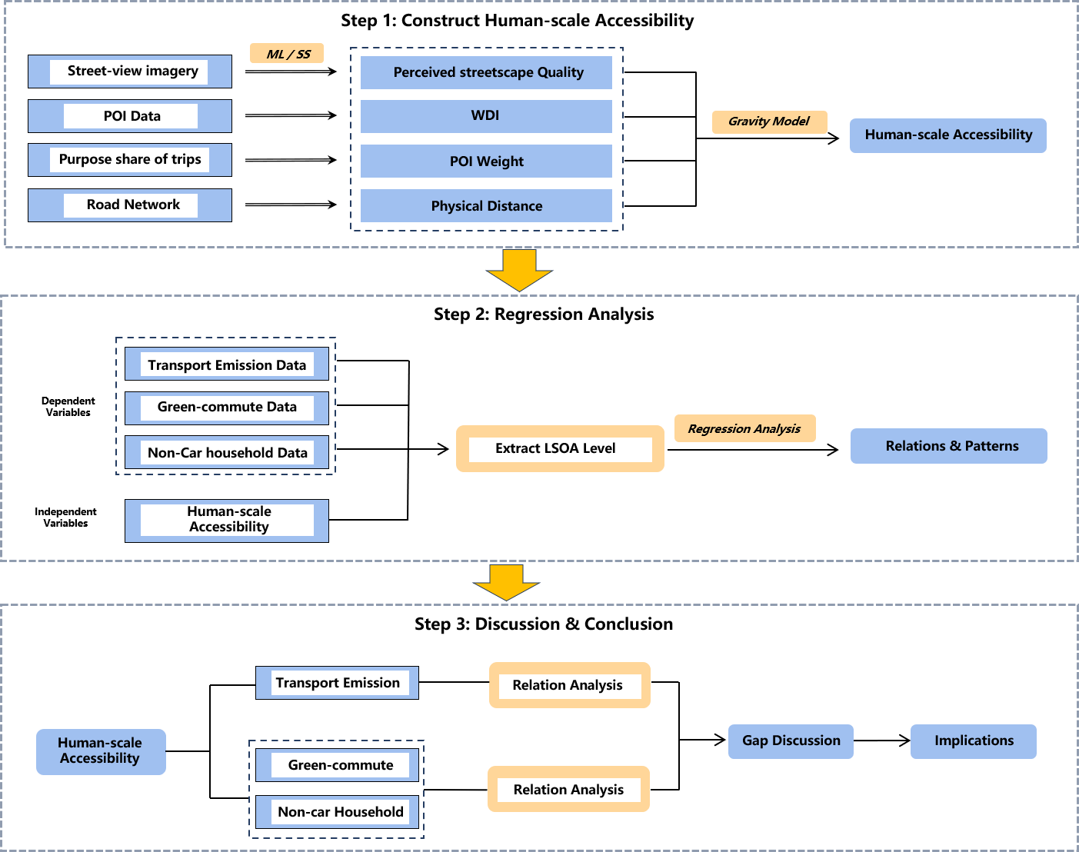

**Figure 1. 1:** Overall research Framework

## 1.3 Scope

The 15-minute city concept has numerous inherent attributes, but this study focuses solely on those related to residents’ daily life, aligning with the initiative's original objectives. Similarly, while it offers various positive effects (e.g., economic growth, well-being, crime reduction), this research specifically examines its impact on mitigating traffic emissions—whether it fulfills the initiative's initial intent.

The Human-Scale Accessibility (HSA) index is a relative measurement that quantifies spatial quality at a specific level, not necessarily representing the actual living experience. Therefore, its role is indicative—best viewed as a valuable starting point for discussion or a guiding tool in the decision-making process, rather than an absolute assessment of the existing environment.

Furthermore, due to time and resource constraints, the proposed model in this study is a preliminary version that does not account for the differentiated impact of parameters. However, the results suggest that the general conclusions drawn still have strong explanatory power for reality.

## 1.4 Ethical Consideration

This study does not involve active participants; all data used are secondary data freely accessible on public platforms. It is important to note that the street view images used in this research were downloaded through the Google API. While the original images may contain some unprocessed private information (e.g., faces, indoor environments), all such information has been equally removed through data processing methods like image semantic segmentation. To prevent privacy breaches, we deleted the original image set after data processing.

Moreover, the parameters included in the HSA model only reflect the level of certain spatial characteristics within a fixed range of the street (walkability and accessibility at the pedestrian scale). However, real urban spatial structures are highly complex, and thus, the model risks not accurately reflecting the actual efficiency of daily spatial use. Nevertheless, the risk of negative effects arising from this study is considered to be extremely minimal by the fact that this research would not be solely used in planning decisions.

# Literature Review

## 2.1 “15-minute city” Initiative and Sustainable Development

Urbanization remains one of the greatest challenges for contemporary and future cities. Over 55% of the global population lives in urban areas, and this is expected to rise to over 68% by 2050 (UN-Habitat, 2020). Notably, more than 60% of global greenhouse gas (GHG) emissions come from urban areas, with vehicular traffic accounting for 78% of these emissions. Reducing urban transportation emissions is crucial for every sustainable development. By 2050, the global demand for natural resources is projected to reach 90 billion tons, up from 40 billion tons in 2010 (Swilling, 2018). This puts cities at the forefront of climate change initiatives (Allam et al., 2020; Allam & Jones, 2019) and socio-technical transformations. Urban stakeholders must play a crucial role in the deep decarbonization agenda, a major theme of COP26, which calls for achieving net zero emissions by 2050 (UNFCCC).

The structure and development patterns of contemporary cities are key sources of environmental problems. Increasing global evidence shows that GHG concentrations are rising rapidly due to current energy-dependent lifestyles and emerging social trends in urban living (Lamb et al. 2021; Seto et al. 2014; Wang et al. 2019). Therefore, the spatial structure of urban activities and residents' behaviors must urgently change to achieve not only environmental benefits but also social and economic gains for sustainable development.

Additionally, urban stakeholders must urgently consider the goals of Sustainable Development Goal (SDG) 11, which emphasizes inclusivity and equity in urban areas (UN Environment Programme). Urban transformation requires long-term planning and substantial investment, increasing the local financial burden. Thus, models that involve the private sector and yield positive social outcomes may be preferred. One promising model is the "15-minute city," proposed in 2016 and popularized after the COVID-19 pandemic (Allam et al. 2022). This concept integrates smart city elements, aims to reduce resource usage, and supports decreased travel demand by increasing population density and activity. To support this, public services and amenities must be equitably distributed and reorganized to promote healthy interactions and social cohesion (Zaheer, 2020; Allam, 2019) within a 15-minute walk or bike ride. Such urban spatial structure will enhance the quality of life in communities. However, a key issue that how to efficiently measure the spatial structure of 15-minute city practice and its effects on emissions still remains unresolved.

## 2.2 Reflection of 15-minute City

The 15-minute city concept, which aims to create compact, mixed-use communities with essential amenities accessible within a 15-minute walk, has gained significant traction in global urban development discourse (Allam et al., 2022; Khavarian-Garmsir et al., 2023; Logan et al., 2022). This concept has been embraced by numerous megacities worldwide, including Paris (Moreno et al., 2021), Toronto (Yu, 2023), and Shanghai (Wu et al., 2021). By reshaping the built environment, urban structure, and travel patterns, the 15-minute city concept is lauded for its potential to reduce travel distances and reliance on private vehicles, thus contributing to the mitigation of road traffic emissions (Allam et al., 2022). While existing research has explored the influence of the built environment and urban structure on road carbon emissions (Sun et al., 2020; Yang, 2023; Yang & Cao, 2018), the direct and quantitative relationship between the 15-minute city concept and emissions has not been thoroughly investigated.

Prior to investigating the quantitative relationship, it is necessary to quantify the 15-minute city level. One central debate is how to understand the spatial structure of 15-minute communities and further measure their efficiency, with related research focusing on walkability assessments. Walkability refers to the pedestrian-friendliness of an urban environment, typically reflected in the accessibility of amenities and the quality of perceived environment. They are two key factors influencing travel behaviour and mobility in daily life.

Measure urban spatial patterns through indices is not new, various indices are created for different purposes (Kaza, 2013), which is considered as a traditional and effective method to investigate cities. However, due to data acquisition challenges, relevant studies have diverged into two methodological extremes when measuring walkability, or the 15-minute city level. One approach is quantitative assessment, using geographic information data to construct indicators at a macro level, such as the well-known 5D principles (density, diversity, design, destination accessibility, and distance to transit) (Cervero & Kockleman, 1997; Ewing & Cervero, 2001; Ewing & Cervero, 2010). This method evaluates walkability across large areas but does not consider pedestrians' actual experiences walking on streets. Measurements of density and diversity are based solely on physical distance, failing to reflect the true efficiency of urban walking spaces. The other approach is qualitative research, using surveys, focus groups, and in-depth interviews to gather evaluations of environmental perceptions, combined with pedestrian flow data for factor analysis (Ewing et al., 2006; Ewing & Hany, 2009; Mehta, 2008; Kelly et al., 2011). This method focuses on pedestrian experiences but has complex data collection processes that are challenging to apply to large areas, and individual subjective differences make generalizing conclusions difficult. Therefore, there is an urgent need for reliable methods to assess walkability. Such method should be based on big data and quantitative approaches, integrating perceptual experiences with macro accessibility.

## 2.3 Define and Measure Accessibility at Human Scale

### 2.3.1 The Gravity Model of Accessibility

Accessibility reflects the proximity of urban structures and are used as key indicators for understanding the characteristics of 15-minute communities. Accessibility indicates the ability that people get to places. It is widely applied in urban planning, transportation planning, and public service facility allocation to assess spatial equity and optimize resource distribution. Streets with high accessibility attract more pedestrian flow and commercial activities, reducing dependence on private vehicles and mitigating traffic congestion as well as environmental pollution (Geurs & van Wee, 2004), also stimulating street vitality and enhancing the economic value and public health of surrounding areas (Litman, 2017; Frank et al., 2006). This study adopts an accessibility perspective and constructs the "human-scale accessibility" (HSA) indicator to more comprehensively measure street’s “15-minute city” level.

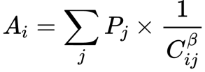Gravity model is originally proposed by Hansen (1959), positing that an area's accessibility is positively related to the number of activities or users and negatively related to travel cost attributes. It is regarded as an effective approach for measuring accessibility for it considered both destination attractiveness and travel impedance. It has been widely used in accessibility research owing to its simplicity and strong explanatory power (Stewart, 1947; Hansen, 1959; Ingram, 1971; Vickerman, 1974; Handy & Niemeier 1997; Geurs & van Wee 2004). The fundamental formula is as follows:

**(1)**

Where Ai: Accessibility of area i; Pj: Quality of area j. For instance, population, job, or other activities; Cij: Travel cost from area i to j. For instance, distance, time, price or other impedances; β: Distance decay parameter.

The model establishes fundamental relationships among key elements and has been proven effective in empirical studies (Stewart, 1947; Hansen, 1959; Ingram, 1971; Vickerman, 1974; Levinson & Kumar, 1994; Handy & Niemeier, 1997; Geurs & van Wee, 2004). In this research, we redefine the attractiveness factors to include perceived environmental quality, POI characteristics, and other relevant variables. Consequently, the model will be adapted to calculate the street-level "human-scale accessibility" index.

### 2.3.2 Attractiveness: Streetscape Quality

Attractiveness factors refer to the characteristics of a destination that attract or drive travelers. The increased attractiveness motivates travelers to overcome impedances to reach the destination.

The urban environment influences walking behaviour through a psychological impact, as people are more inclined to expose themselves to environments that make them feel comfortable. Researchers suggest that perceived urban environmental characteristics (e.g., open spaces, building density, walkability, aesthetics, mixed land use) have been shown to benefit mental health (Gidlow et al., 2010; Leslie & Cerin, 2008; Qiu et al., 2019; Wood et al., 2017). Alfonzo's (2005) hierarchy of walking needs theory highlights the influence of the perceived environment on walking decisions (**Figure 2.1**). Similarly, Gehl (2010; 2011) emphasizes the positive impact of a well-perceived environment on human travel behaviour. He further proposed 12 street quality criteria (**Table 2.1**) from three dimensions: protection, comfort, and enjoyment. These criteria essentially encompass the perceived elements and summarize the characteristics of high-quality street environments at a human scale. The influence of street environment can be observed in reality: people tend to walk farther in pleasant environments, while in poor environments, they lose interest in walking and may even deliberately take detours to avoid areas that make them feel uncomfortable. Therefore, it is necessary to consider the long-overlooked factor of "perceived environment" when measuring the 15-minute city.

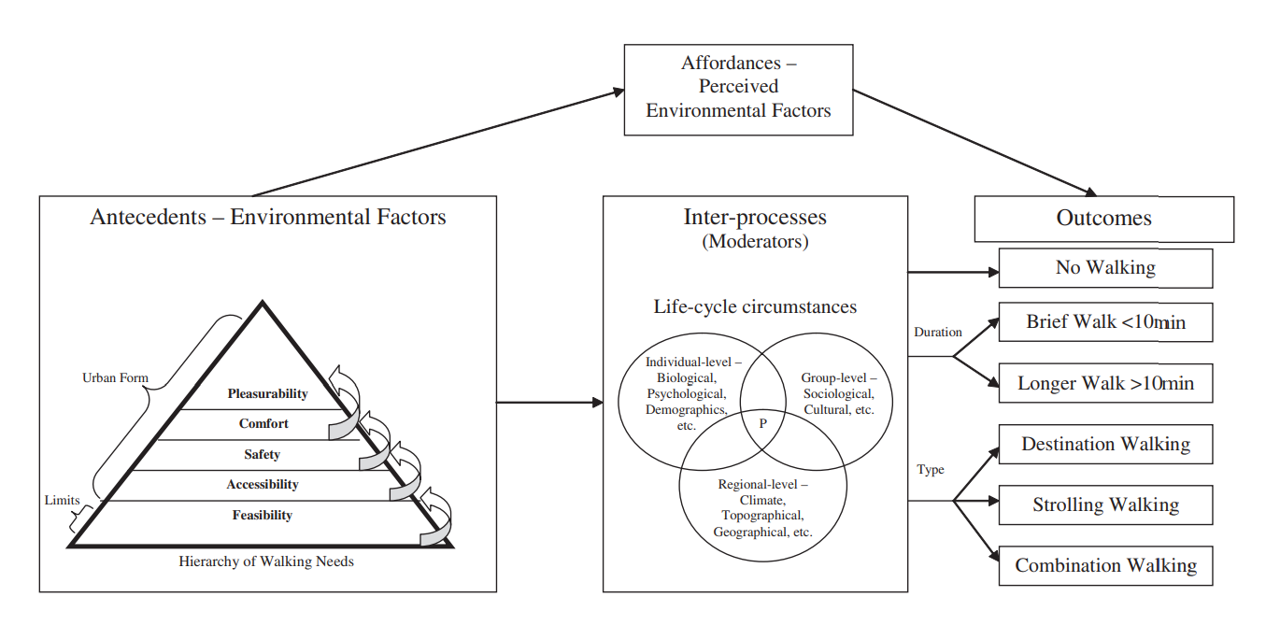

**Table 2. 1:** 12 street environment quality, adapted from Gehl (2011)

**Figure 2. 1:** Hierarchy of Walking Needs: how perceived environment influence walking behaviour (Alfonzo, 2005)

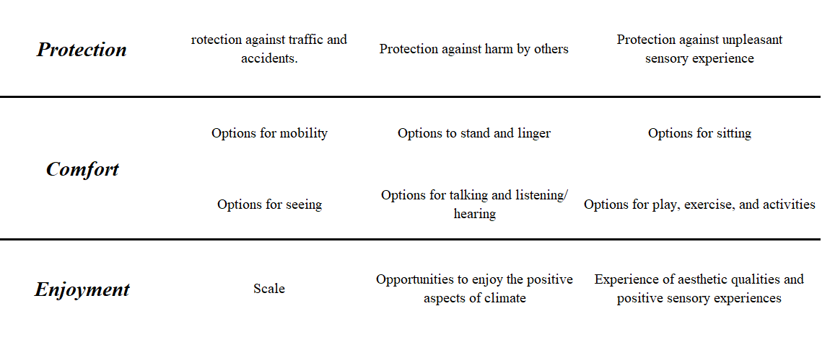

As these perceptions are inherently subjective assessments, most current studies tend to employ qualitative methods to evaluate perceived streetscape quality, with the most common approaches including expert panels, questionnaires, and site observations (Ewing & Handy, 2009). However, such methods are inefficient for large-scale assessments and prone to subjective biases, making generalization difficult.

Pedestrians' perceptions of the environment are predominantly derived from visual elements (Ewing & Handy, 2009; Gehl, 2010; Adkins, 2012; Yin, 2017). In recent years, with the enrichment of big data, emerging behavioral accessibility measurement methods have rapidly developed. The significance of Google Street View in urban environment studies has grown, particularly with the increasing use of this imagery in conjunction with technologies like image semantic segmentation and machine learning for urban space quality assessment, including the Green View Index (GVI) (Yang et al., 2009; Dong et al. 2018; Yang et al., 2019; Wu et al. 2020; Xia et al. 2020), walkability (Blečić et al. 2018; Nagata et al. 2020; Bartzokas-Tsiompras et al. 2020), and urban perception (Li & Long 2019; Liu et al. 2019; Wu et al. 2020; Ye et al. 2019). These technologies provide new possibilities for quantitatively analyzing the perception quality of urban spaces.

### 2.3.3 Attractiveness: Social Activity/Thirdspace Quality - POI

"Cities are about people, not buildings" (Jacobs, 1961). Jacobs emphasized the importance of human activity in creating urban life, indicating that the vibrancy and happiness produced by spontaneously formed lifestyles are the essence of urban vitality. Soja (1998) expanded on this relationship in his Thirdspace theory, suggesting that the convergence of physical and perceived spaces—Thirdspace—resembles a lifestyle cultivating mutual shaping and broad cultural identity. The social activities encompass all potential forms of daily activities facilitated by the physical space, including shopping, walking in parks, socializing in bars, and more. The social activity serves as key characteristics of a 15-minute city, with environmental quality serving as driving forces that encourage people to engage in these social activities. Therefore, the social activity is the key attractiveness factor that influencing 15-minute city initiatives, needs to be quantified.

Points of interest (POIs) are the primary destinations for daily travel, and their density and diversity reflect urban vitality, influencing population mobility and distribution (Cranshaw et al., 2012; Yuan, 2012; Batty, 2013; Yue et al., 2017). They serve as the main attractiveness of residents’ daily movement, as people need to satisfy basic material and social needs through activities such as shopping and socializing.

POI data are frequently used to quantify the level of social activities or infrastructure in a given area (Batty, 2013; Cranshaw et al., 2012; Yuan, 2012). It is further utilized to quantitatively investigate the relationship between local 15-minute city levels and human mobility, socioeconomic factors, and other elements (Graells-Garrido et al., 2021; Abbiasov et al., 2024; Li et al., 2024). Consequently, this study uses POI data to quantify the level of social activities, focusing primarily on three attributes: scale, quality, and diversity:

(1) The scale or number of opportunities at a destination is widely regarded as an important attractiveness factor influencing accessibility (Handy & Niemeier, 1997). For instance, employment accessibility studies often measure the attractiveness of employment centers by the number of jobs (Shen, 1998), while commercial accessibility studies commonly use the number of stores or retail area to represent the attractiveness of commercial centers (Huff, 1963). Kwan (1998) pointed out that the attractiveness of a destination is proportional to the number of opportunities it provides; the more opportunities, the greater the attractiveness to travelers, and the higher the accessibility level.

(2) The quality or service level of a destination is also a crucial attractiveness factor affecting accessibility (El-Geneidy & Levinson, 2006). For example, school accessibility research should consider not only the number of schools but also factors such as teaching quality and faculty level (Talen, 2001). Geurs and van Wee (2004) suggested that accessibility research should comprehensively consider both the quantity and quality dimensions of destinations and construct a comprehensive attractiveness index encompassing scale and quality.

(3) The diversity or functional mix of destinations has also been proven to be an attractiveness factor influencing accessibility (Ewing & Cervero, 2010; Manaugh & Kreider, 2013; Talen & Koschinsky, 2013). Higher diversity implies that travelers can obtain more types of activity opportunities within a smaller range, resulting in shorter travel distances and higher accessibility levels (Maria Kockelman, 1997). For instance, Manaugh and Kreider (2013) adopted the entropy index (Shannon, 1948; s Frank & Pivo, 1994) to measure destination diversity and found that enhancing POI diversity helps reduce travel distances and improve accessibility levels.

### 2.3.4 Impedance: walking distance

Distance is a commonly used impedance factor in measuring the accessibility of a 15-minute city (Graells-Garrido et al., 2021; Abbiasov et al., 2024; Li et al., 2024). The greater the physical distance to reach social activity points (POIs), the lower the likelihood that residents will walk to those destinations. A 15-minute city typically covers a 1–2-kilometer distance, reachable within a 15-minute walk or bike ride (Moreno et al., 2021; Pozoukidou & Chatziyiannaki, 2021).

At the walking scale, network distance represents people's actual travel distance more realistically than Euclidean distance, especially in metropolitan areas with complex road networks (e.g., London), where the actual difference between the two can reach a staggering 2-3 times. When studying human-scale accessibility, network distance must be used to express travel distance. Consequently, the walkable catchment area of a street is no longer a simple circle but rather a range that integrates with the actual road network.

## 2.4 Research Area: London CAZ

This study selects London's Central Activities Zone (CAZ) as the research area (**Figure 2.2**). The CAZ, as London's core, aligns well with the 15-minute city concept. It is a globally iconic and competitive business location, providing one-third of London's jobs and nearly 10% of the UK's output. The CAZ also houses the national government and is renowned for its shopping, culture, and heritage, with over 237,000 residents (GLA, 2016). The Central Activities Zone (CAZ) suffers from poor air quality due to high traffic volumes generated by its dense road network and land use (GLA, 2016). Simultaneously, the area is characterized by a predominance of walking and cycling; for instance, Oxford Street experiences over 100,000 walking trips daily, Cannon Street has a pedestrian modal share exceeding 80%, and an average of 230,000 people walk across the River Thames each day (GLA, 2016). The CAZ embodies two core features relevant to this study: atmospheric emissions and an environment conducive to walking.

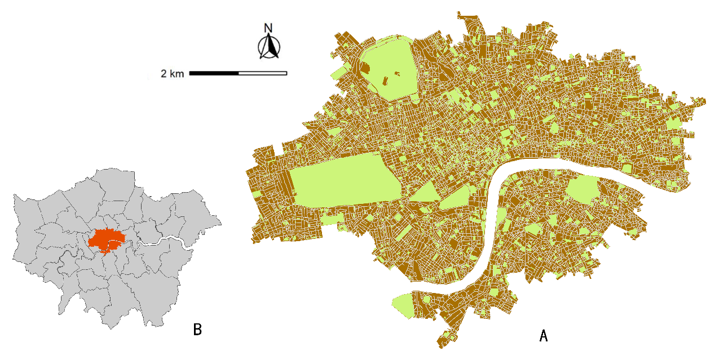The London Plan (2021) calls for practical measures to improve air quality in the CAZ and emphasizes the area's concentration and diversity of social activities. It encourages diverse land use to ensures the coexistence and complementarity of different functions.

**Figure 2. 2:** Research Area, London CAZ. A illustrates road network and POI distribution. B illustrate its location in Greater London

The document also emphasizes attractiveness and inclusivity for residents and visitors. The high-density, compact development of London's CAZ, with its "people-centric" initiatives, aligns with the 15-minute city's green and sustainable principles. The 15-minute city concept have certain potential to be effectively applied here. The “human-scale accessibility” index is expected to help planners identify areas within the CAZ that are weak in sustainable development at the street level guiding rational investment and regional development plans to create livable cities and further reduce transport emissions.

## 2.5 Summary

Before achieving a zero-carbon transition, urban transport emission will continue to threaten the global climate. SDG 11 emphasizes improving urban quality of life by reshaping infrastructure and promoting social inclusion (Allam et al., 2022). These goals align with the 15-minute city initiatives. However, there is limited empirical evidence and understanding of the initiative's effectiveness in reducing traffic emissions. Furthermore, there is currently no systematic and efficient method to quantify the level of 15-minute city implementation. Consequently, we need a new quantitative method to measure the 15-minute city level from a perspective of urban spatial structure. This study aims to develop such indicator called "human-scale accessibility" (HSA), using street view images, POI data, and road networks. The study chooses London's CAZ as the research area, and further explore the relationship between human-scale accessibility, transport emissions, health, and green travel modes.

The index "human-scale accessibility" (HSA) can serve as an effective evaluation tool for 15-minute city practices. This method relies on general public data, has the potential to apply on broader city contexts.

# Methodology

## 3.1 Outline and Framework

The 15-minute city concept encompasses multiple dimensions. The Human-Scale Accessibility (HSA) index aims to integrate these key dimensions into a single measure, serving as a representative quantitative indicator of the phenomenon. As new data types become increasingly available, methods for quantifying urban characteristics are becoming more prevalent (Bassolas et al., 2019; Graells-Garrido et al., 2021; Cabrera-Arnau et al., 2023; Abbiasov et al., 2024). Development patterns and social phenomena have intricated underlying connections. Constructing quantitative indicators of urban characteristics related to specific phenomena is a challenging task involving numerous steps and variables. Ensuring the qualitative rationality of selected variables and the generalizability of quantitative models is crucial. Each step, variable, and the calculation and processing of variables must undergo rigorous and meticulous evaluation. Only through thorough conceptual clarification and empirical validation can scientifically sound, reliable, and effective quantitative indicators of urban characteristics be developed, providing powerful tools for depicting and understanding urban phenomena.

Through a literature review, we summarized the main characteristics and evaluation framework of the 15-minute city based on the specific research objective of reducing traffic emissions. The methodology section can be divided into four main stages: data collection, data pre-processing, data processing, and regression analysis. The **Figure 3.1** presents an outline of the data processing and analysis in this section. Data sources include Google Maps, OpenStreetMap (OSM), Place Pulse 2.0, ONS, and GLA platform. The primary quantitative methods employed are machine learning, network analysis, generalized linear regression (GLM), and geographically weighted regression (GWR).

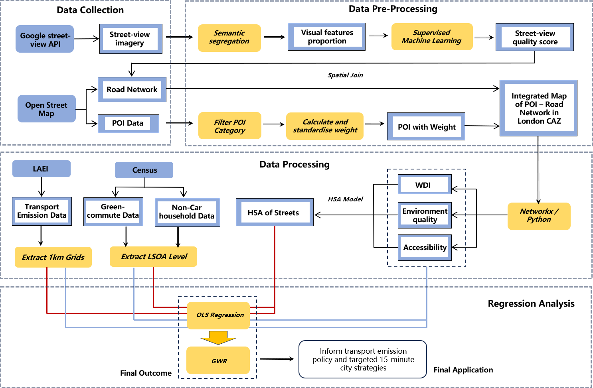This section describes how to construct the "Human-Scale Accessibility" index which quantifies 15-minute city level at the street level. The ultimate goal is to investigate the relationship between the 15-minute city level and local traffic emissions. A deep understanding of this relationship helps planning authorities adjust planning and transportation development strategies to support emission reduction targets in central urban areas, maximizing the benefits of public investments in reducing traffic emissions. The analysis is primarily conducted using Python, and reproducible analysis code and processes can be accessed via GitHub: [github.com/ZimengSong1996/15m-city_HSA_Emission_LondonCAZ](https://github.com/ZimengSong1996/15m-city_HSA_Emission_LondonCAZ)

**Figure 3. 1**: Framework of 4 stages: data collection, data pre-processing, data processing and regression analysis

## 3.2 Adapted HSA model

We employ the accessibility gravity model (Hansen, 1959) to construct "human-scale accessibility" (HSA, Formula 2) which measures the street-level urban activity structure encompassing both perceived environmental quality and amenity accessibility dimensions. Streetscape quality and POI features are two attractiveness factors positively correlated with accessibility in this model. The model considers the combined impact of POI quantity, weight, and diversity within walking range (1000 meters). Studies show that walkable urban structures rely on diverse urban facilities (POIs) (Handy & Clifton, 2001; Geurs & van Wee, 2004; Manaugh & EI-Geneidy, 2012). Therefore, we introduce the Weighted Diversity Index (D) (Shannon, 1948; Magurran, 2021; Zhou & Kockelman, 2008) to measure POI diversity within the 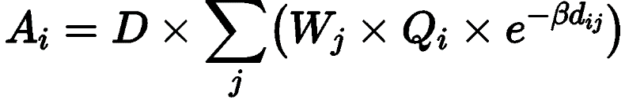walking distance of a street.

**(2)**

Where Ai: human-scale accessibility; Wj: weight of category j of POI; Qi: average streetscape quality in catchment of street i; dij: distance from i to j; β: distance decay parameter, determine the influence of distance d; D: Weighted Diversity Index (WDI). The human-scale accessibility (Ai) is on street level. For streets, it calculates each POI within its walking range by Wj, Qi, dij, then add them and multiply with D.

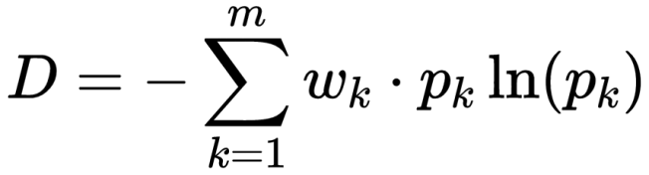The prototype of the WDI (Formula 3) is the Shannon Diversity Index (Shannon, 1948), which extends the latter's concept by introducing weights that more accurately reflect the contributions of different types of POIs to overall diversity (Magurran, 2004; Zhou & Kockelman, 2008). WDI has significant applications in urban planning, transportation analysis, and the layout of public services (Li & Yeh, 2004; Levinson & Krizek, 2008). Here, the weights Wk and Wj have same meaning, are calculated in different scenarios.

**(3)**

Where m: Number of POI categories; pk: proportion of POI in k-th category, in total number of POIs; wk: weight of POI in k-th category.

Therefore, the comprehensive human-scale accessibility model can be represented by the following formula 4:

**(4)**

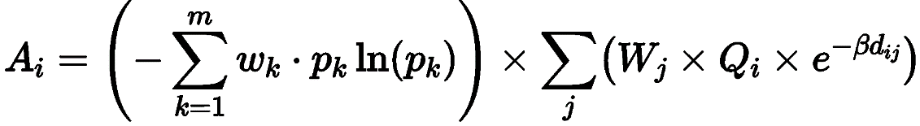

## 3.3 Data Processing

### 3.3.1 Data

When constructing quantitative indicators, data availability and representativeness are of utmost importance, directly influencing the effectiveness of the indicators. HSA index is a comprehensive indicator integrating objective and subjective geospatial dimensions, utilizing a diverse range of data types (**Table 3.1**). These data are collected from various open data platforms, and ArcGIS is used to reproject geodata when necessary, clean and extract dataset contents accordingly, and perform point, line, and polygon overlay analyses to process the multidimensional characteristics of the 15-minute city.

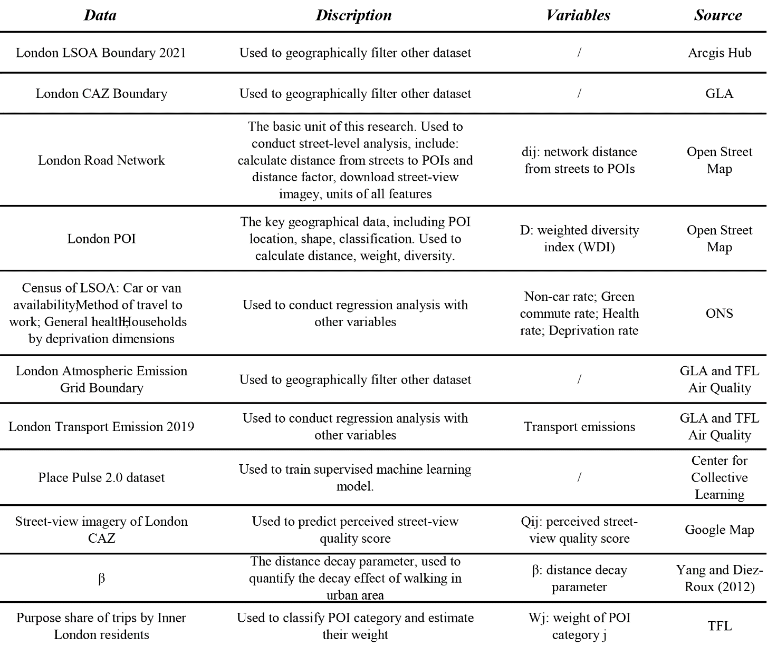

**Table 3. 1**: Data sources, type and description

Boundary data are primarily used for filtering and matching other data. The road network and POI data within the study area are the main focus of the research, with the primary computational data (perceived quality score, POI weights, etc.) being matched and linked to them. The process of downloading and processing the street view image collection for the study area was time-consuming with approximately one month, involving a total of 184,828 images. Transport emission and census data serve as dependent variables in the regression analysis, exploring their relationship with the HSA index.

### 3.3.2 Study Area Adjustment

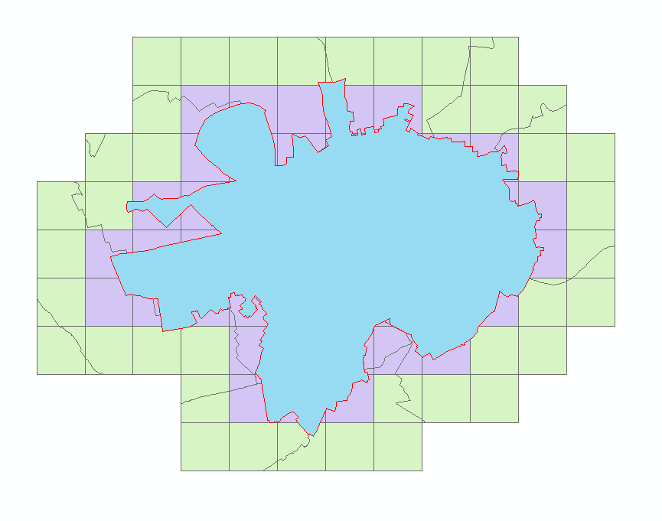The selection of the study area is based on a three-layer geographical boundary system (**Figure 3.2**). The first layer is the boundary of the CAZ (blue), the second is the transport emission statistical grid covering the CAZ (purple), and the third is the buffer boundary region (green). To align with the transport emission statistical units for the final regression analysis, the original CAZ has been appropriately expanded (purple + blue). Furthermore, as the HSA index is calculated at street level, involving all elements within a 1km network distance of each street, we extend outwards again using 1km grid units to establish a buffer zone (green area), which serves as the final data collection area for street view images, road networks, and POIs.

**Figure 3. 2**: Boundary of CAZ (Blue), research area (Purple) and buffer zone (Green)

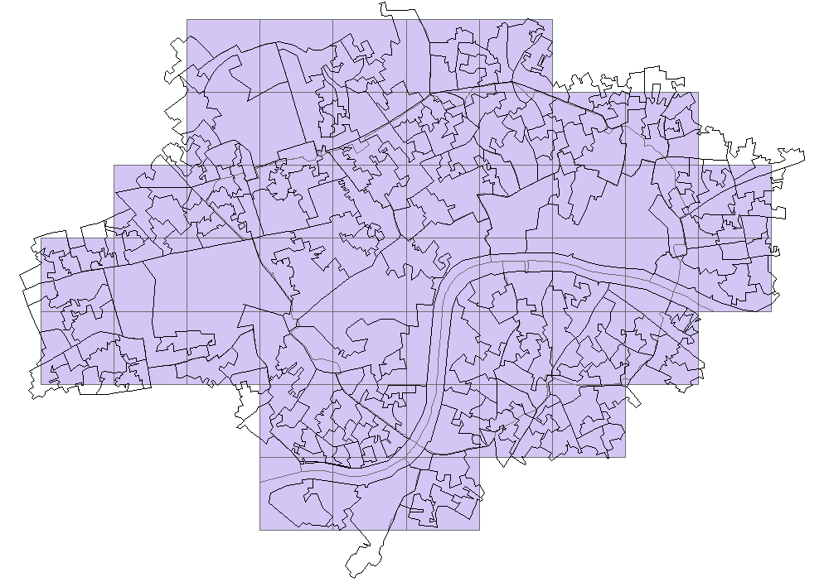The final study area is a 1km grid region encompassing the CAZ (**Figure 3.3**). We will calculate the HSA index for all streets within this area and determine the average HSA level within each grid cell. These values will be used in a regression analysis with the corresponding transport emission levels in each grid cell. Another spatial unit is the Lower Layer Super Output Area (LSOA). Based on the study area, we consider LSOAs with more than 50% of their area covered as valid and retain them (**Figure 3.3**). The average HSA level within each LSOA will be calculated and used in a regression analysis with the Socio-Green indicator.

**Figure 3. 3**: Research area (Purple) and London LSOA boundary (2021)

### 3.3.3 Perceived Streetscape Quality

The perceived environmental quality is a crucial attractiveness factor (Qi) in the HSA model, representing the average perceived environmental quality within the walking range of street i. This study employs a supervised machine learning approach based on image semantic segmentation to predict the perceived quality scores of streets. This study focuses on London's CAZ and samples approximately 43880 street view points at 100-meter intervals. We downloaded about 184828 street view images using the Google API. We then trained a supervised machine learning model to evaluate the 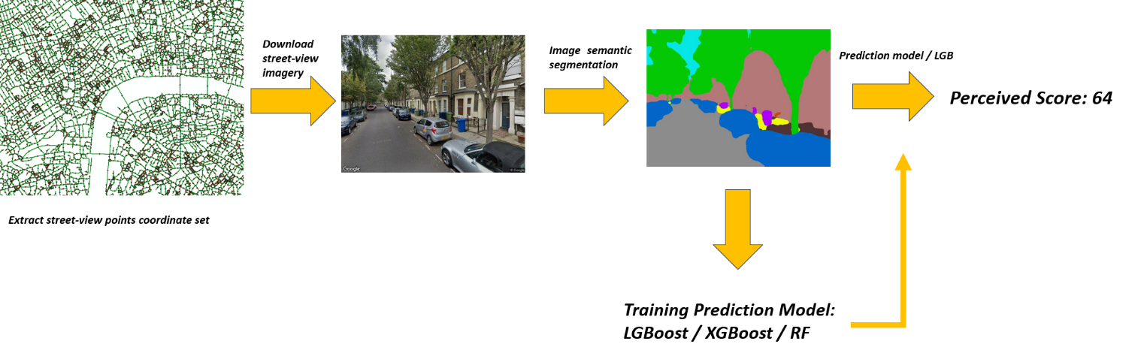quality of these images. A general workflow as following (**Figure 3.4**).

**Figure 3.4**: Workflow of the street-view analysis, prediction of perceived environment quality score

*3.3.3.1 Imagery Semantic Segmentation*

Image semantic segmentation involves dividing an image into multiple semantic regions and classifying each pixel, ensuring that pixels of the same category belong to the same semantic label (Long et al., 2015). ADE20K is the largest open-source dataset for semantic segmentation and scene parsing, released by MIT Computer Vision team. We used an image semantic segmentation model using PyTorch that pre-trained on the ADE20K dataset to process the Place Pulse 2.0 dataset, categorizing street view elements into 50 classes (**Table A.1**) and calculating the visual proportion of each class in the images. These visual proportions served as predictor variables for machine learning training. The original model can be found: [github.com/CSAILVision/semantic-segmentation-pytorch](https://github.com/CSAILVision/semantic-segmentation-pytorch)

*3.3.3.2 Training Predictive model*

We used the Place Pulse 2.0 dataset to train the “perceived quality predictive model”. This open-source dataset, created by the Center for Collective Learning, includes 111390 street view images at 90º and their perception scores across six dimensions (**Table 3.2)**. The research team collected images from 56 cities worldwide to evaluate 6-dimension perceived qualities. Using Amazon Mechanical Turk, the team recruited volunteers for an online survey where participants compared two randomly presented street view images and chose one based on a perception question. Each image was compared with several others, and the TrueSkill algorithm calculated scores for different perception dimensions based on these comparisons. The dataset is widely used in street view research and includes representative cities globally. To match the 90º images in the dataset, we also download the street-view images set with 90º. Each street view point had four 90º images, and the average score of four images was used 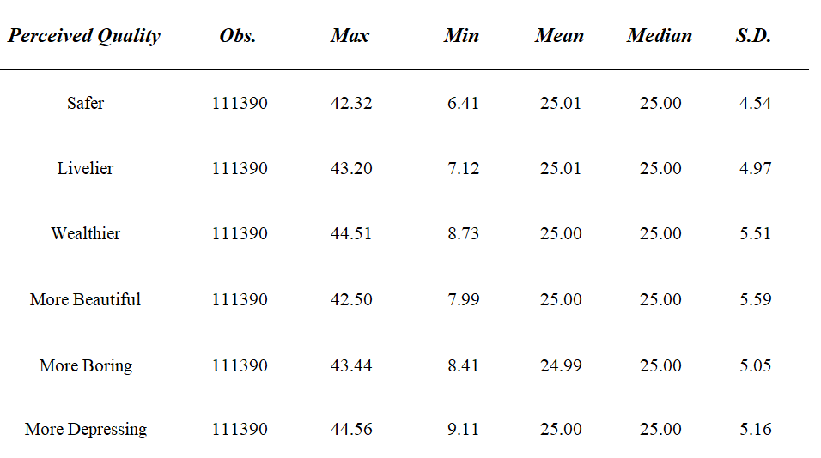as the perceived quality score for the point.

**Table 3. 2**: Six dimensions of perceived environment quality score in Place Pulse 2.0 dataset

Among the six dimensions of perceived quality, there are four positive scores and two negative scores (More boring and more depressing). The selection of dimensions to be included in the scoring should be based on the research objectives. Ideally, the total perceived score of an image should be calculated by subtracting the two negative scores from the four positive scores. However, the most representative score combinations that maximize model prediction accuracy need to be experimentally verified.

We trained 3 machine learning models to compare their performence (**Table 3.3**). We employed five-fold cross-validation for 3 models. In each fold, 80% of the data was used for training, and 20% was used for validation. We measured the model's performance in predicting the validation set and repeated this process five times, each time with a different 20% of the data as the validation set.

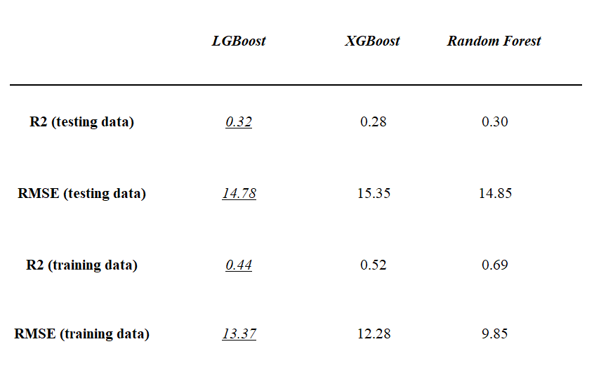The LGBoost model outperforms XGBoost and RF on the test set in terms of R2 and RMSE, and the difference in R2 between the training and test sets is smaller, indicating that LGBoost has stronger generalization ability and lower risk of overfitting (Hawkins, 2004; Hastie et al., 2005). Therefore, we choose LGBoost model to process the prediction of perceived quality score.

**Table 3. 3**: Three supervised machine learning model for predicting perceived quality score

To validate the modeling performance of different combinations of 6 perceived dimensions, we used five sets of score labels formed by different perceived dimensions’ combinations for LGBoost modeling and prediction. Their performance on the test set is shown in the **Table 3.4**. R2 decreases as the number of dimensions decreases. The results indicate that using the total perceived score obtained by subtracting the sum of two negative scores from the sum of four positive scores as the training label yields the best modeling results. Furthermore, the phenomenon that reducing the perceived dimensions unilaterally leads to a decline in model performance also demonstrates the validity of the dataset: the subjective ratings of the six dimensions have continuity and reliability. Therefore, we choose to use the "4 positive – 2 negative" method as the final perceived score label for the images.

**Table 3. 4**: Five types perceived quality score definition for training label

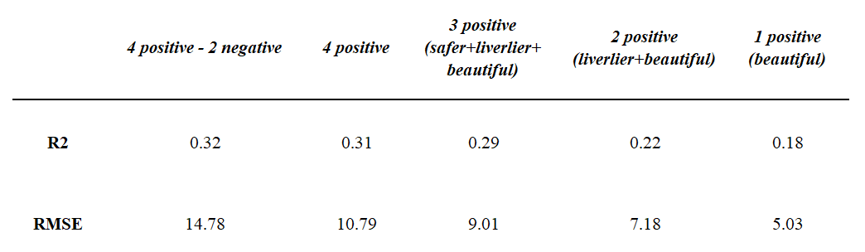

The feature importance of LGBoost model reveals that the influence of all elements is below 0.1, with notable differences among them (**Figure B.1**). Elements such as buildings, roads, sky, and trees (id2, id7, id3, id5) have a higher impact on perception, while elements like skyscrapers, cars, and chairs (id49, id21, id20) have a lower influence.

*3.3.3.3 Predict Perceived Environment Quality Score*

Google Street View images of the study area were downloaded, and indoor or blank images were removed. The corrected image set underwent semantic segmentation to obtain predictor variables. The predictive model was used to generate predicted score for each image. Then we calculate the average score of four 90º images as the final score of each street view point. Results are shown in the **Table 3.5** and **Figure 3.5**.

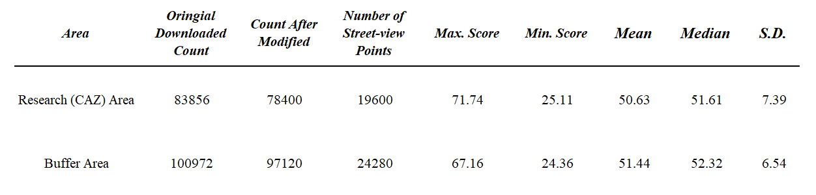

**Table 3. 5**: Predicted perceived quality score in research area and buffer area

The quality scores for both the study area and buffer zone exhibit a near-normal distribution, indicating overall continuity in score quality. Nearly 70% of the street viewpoints have perceived quality scores between 45 and 60, with less than 25% of the scores exceeding 60.

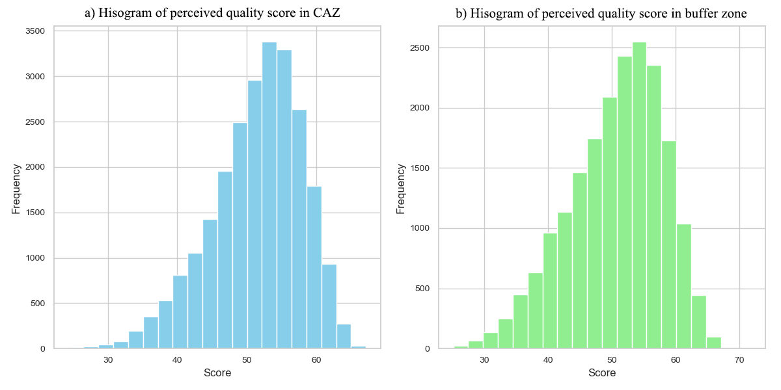The perceived quality scores were joined to the street view points by FID and then spatially joined to the corresponding streets using ArcGIS, resulting in perceived quality scores for all streets.

**Figure 3. 5**: Histograms of perceived quality score in CAZ (a) and buffer zone (b)

### 3.3.4 POI Category Weight

The weights (Wj) of different POI categories are estimated using the proportion of trip purposes published by TFL (2011), which categorizes residents' travel purposes in inner London into six types, with statistical proportions for each (**Table 3.6**).

**Table 3. 6**: Purpose share of trips by Inner and Outer London residents (Transport for London, 2011)

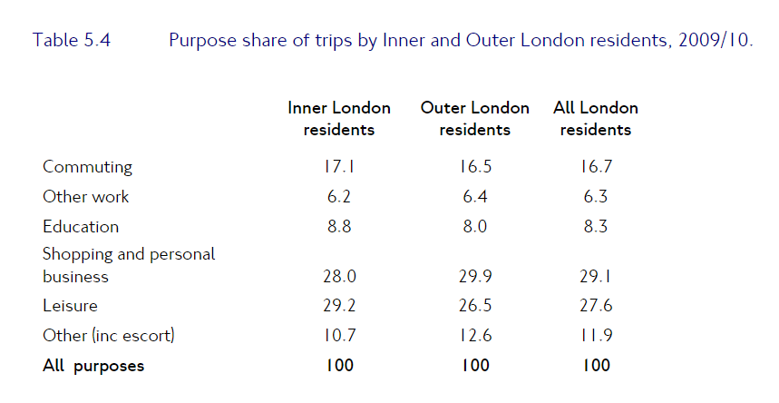

In the OSM dataset, London's POIs are divided into over 100 classifications. Some unconventional classifications, such as surveillance cameras, bicycle rental points, and chairs, were removed, retaining only those POIs that serve as travel destinations, such as shopping, entertainment, and education. People's daily usage frequency varies for different POI functions. Based on people's daily travel purposes and frequencies, each category has a relative proportion (TFL, 2011). Due to the integration and diversification of POI functions, people's purposes for visiting specific POIs may also be diverse. We employed a qualitative estimation method based on experience to reasonably allocate the proportion of each POI category according to travel purposes and further estimate their weights (**Table C.1**).

### 3.3.5 Network Distance & Decay Parameter

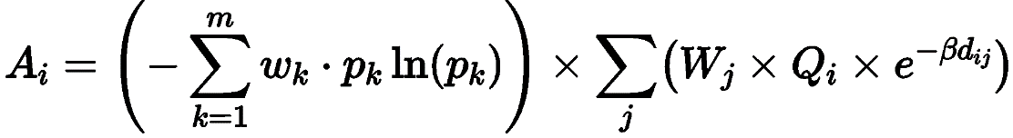This study uses the Python-based Networkx library for street network calculations. The HSA model (Formula 4) describes the quantified urban structure at the walking scale, where network distance accurately represents walking behavior and its decay effect. The study involves over 90,000 streets, and directly calculating network distances from each street to all POIs within its reach using Networkx is time-consuming (approximately 31,000 hours). To simplify the network distance calculation, we employ the circuity factor (Levinson & El-Geneidy, 2009; Giacomin & Levinson, 2015; Huang and Levinson, 2015; Cubukcu, 2021). We randomly select 50,000 point pairs with Euclidean distances within 1,000 meters, calculate the ratio of their network distance to Euclidean distance as the circuity factor, and compute London's overall average circuity factor, which is approximately 2.4. Using the circuity factor, network distances are calculated as the product of Euclidean distance and the circuity factor, largely improving computational efficiency (approximately 21 hours). Based on the circuity factor of 2.4, a street's catchment area is defined as a 500m radius circular range, limiting the walkable network distance to 1,500m.

**(4)**

The distance decay parameter β represents the extent to which walking distance reduces accessibility. It varies based on the context and destination and needs to be measured according to the actual situation. Yang and Diez-Roux (2012) used data from the 2009 National Household Travel Survey (NHTS) to measure β values for different travel purposes in urban areas (**Table D.1**). They calculated that the general value of β for walking in urban environments is 1.78. Therefore, we take β=1.78 as the walking distance decay parameter.

### 3.3.6 Data Matching

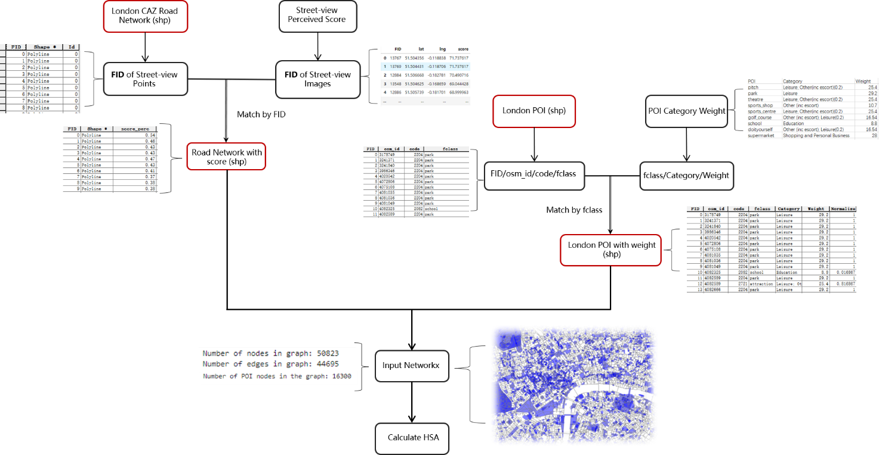Before calculating HSA, all relevant data are joined to the two core shapefiles—the road network and POI polygons—to form a complete shapefile for further spatial computation using Networkx. The data joining process is illustrated in the **Figure 3.6**. In ArcGIS vector layers, each feature has a unique FID. The perceived quality scores are joined to roads using FID, and the weights of POI categories are correspondingly joined to all POI features by “fclass” (classification) column.

**Figure 3. 6**: Data matching process in Arcgis

### 3.3.7 Transport Emission and Socio-Green data

Transport emission and Census data are used as dependent variables to explore their relationship with the regional HSA level. The Census data is at the LSOA (2021) level, representing the local Socio-Green indicators. The ratios of corresponding features were calculated for each LSOA, and their data distribution is shown in the **Table 3.7**. The Transport emission data is at the 1km grid scale, and due to the consideration of borough administrative boundary divisions in the original dataset, it totally contains 128 sub-regions. The emission values represent the average annual emissions per square kilometer. The uneven geographical division of the original dataset leads to a 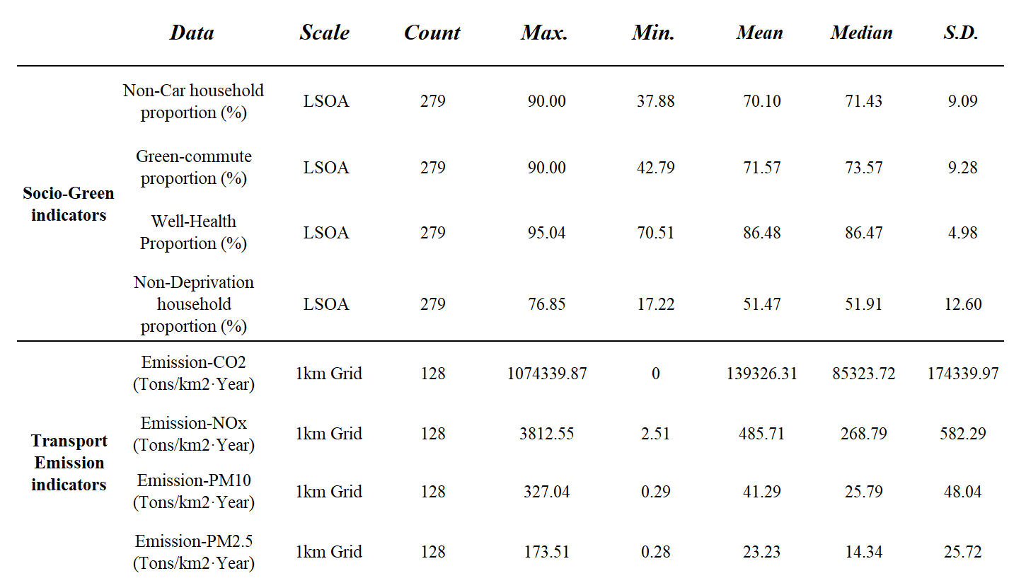large standard deviation.

**Table 3. 7**: Socio-Green and transport emission indicators, dependent variables for regression analysis

The Socio-Green indicators are calculated using the raw census LSOA data. The non-car household proportion represents the percentage of households without cars out of the total number of households in LSOAs. The green-commute proportion indicates the percentage of people in the region who primarily commute by walking, cycling, or working from home out of the total population in LSOAs. The well-health proportion denotes the percentage of people above good health out of the total population in LSOAs. The non-deprivation household proportion represents the percentage of households that are not deprived in any dimension out of the total number of households in LSOA.

## 3.4 Regression Analysis Methods

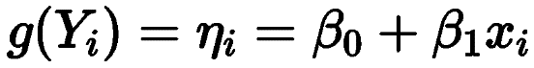The global GLM model reveals the overall linear relationship between HSA levels, transport emissions, and Socio-Green indicators, providing a reference and diagnostic for local models (Brunsdon et al., 1998). Establishing a global model before building a local GWR model is necessary. GLM is suitable when the response variable follows an exponential family distribution (Hastie & Pregibon, 2017). Significance and multicollinearity testing help select a subset of independent variables that significantly influence the dependent variable and are mutually independent (James et al., 2013). The global model also serves as a foundation for comparing and nesting with other models (Hastie & Pregibon, 2017; Leung et al., 2000). The GLM model expression of single variable is as formula 5:

**(5)**

If our premise—that a city is a system of many internal cities—is correct, we should observe that the global model overlooks the peculiarities of each city subsystem. These subsystems differ due to local culture, location, and other factors. For instance, HSA may not be equally important for the non-car household rate in every area, as some areas may have less public transport and jobs, making vehicles a necessity. Entertainment and educational facilities might also influence attracting people to specific areas. The global model may not well-represent these situations, as it enforces a constant factor for the entire city. To consider local variations in the impact of HSA on urban characteristics, the model should incorporate geographical location in its parameters, considering the spatial heterogeneity of the impact. The Geographically Weighted Regression (GWR) model (Brunsdon et al., 1996) is an effective approach. GWR is a kernel regression method for geographically varying phenomena, performing multiple GLM regressions (Brunsdon et al., 1998), one for each analyzed spatial unit. These regressions weight observations based on a kernel function that estimates weights according to the distance to the spatial unit, given a bandwidth. The bandwidth can be defined based on domain knowledge or model selection criteria ****(Comber et al., 2020). The GWR model expression is as formula 6:

**(6)**

Where yi is the response variable for the i-th observation, β0 is the intercept term for the i-th observation point, (ui, vi) is the location of the i-th observation point, xi is the value of the explanatory variable for the i-th observation point, and ϵi is the error term for the i-th observation point.

Based on the GWR results, we will obtain a characterization of the linear relationship between HSA levels and response variables in each spatial unit. If the observed spatial variation in coefficients is small, the impact of HSA is globally uniform, and policy formulation does not need to consider locational peculiarities. In addition to HSA, we will separately model the regression of WDI and perceived quality of streets with transport emissions and Socio-Green indicators, comparing the possibility of impact variables from multiple dimensions.

# Result

## 4.1 HSA Patterns in London CAZ

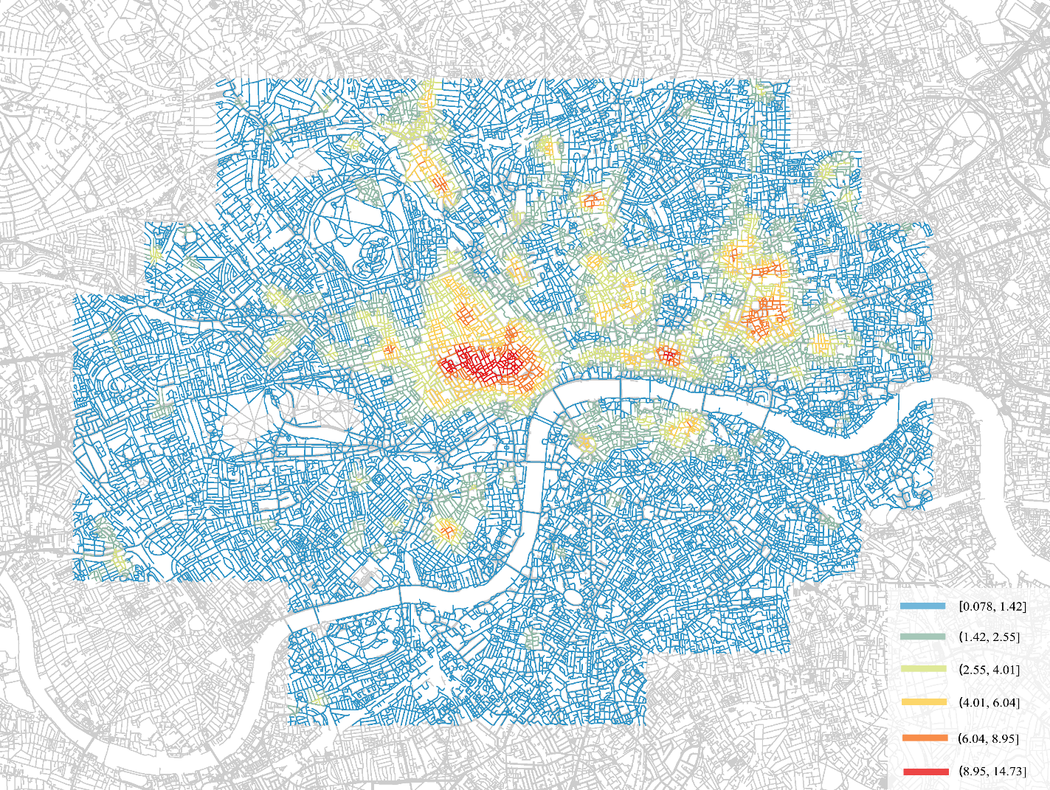The 15-minute city level (HSA) in London's CAZ exhibits clear differences, as evident from the pattern map (**Figure 4.1**). The central areas have significantly higher HSA levels, with a prominent large hotspot near Soho and Covent Garden. Other hotspots are evenly distributed in Camden, City of London, East End, Westminster, South Bank, and other locations. Overall, the areas along the River Thames have higher 15-minute city levels with multiple hotspots. The north bank of the Thames generally has higher levels than the south bank, suggesting a significant imbalance in the development of London's north and south regions. In the peripheral areas of the CAZ, the 15-minute city level gradually decreases, particularly in the western and southern regions, where large areas of low values appear.

**Figure 4. 1**: Human-Scale Accessibility pattern in London CAZ

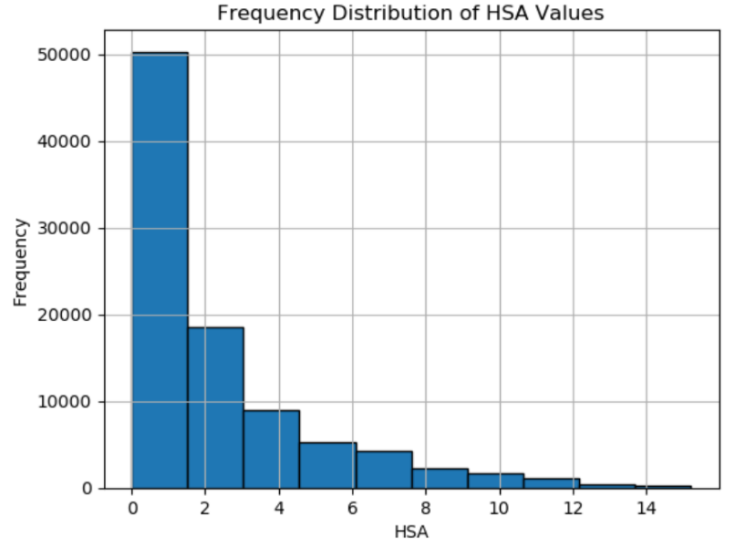The distribution of street HSA values exhibits a clear imbalance (**Figure 4.2**). Approximately half of the streets have HSA values in the range of 0-2, while around 30,000 streets fall within the 2-6 range. Only fewer than 10,000 streets have HSA values greater than 8. Overall, London's 15-minute city level shows a significant disparity, with a small number of well-developed areas far exceeding others, suggesting a substantial imbalance in regional development and a tendency for resource concentration. Most areas have lower HSA values, but this does not necessarily imply that these places fail to meet the daily needs of a 15-minute city, which will be further discussed later.

**Figure 4. 2**: Histogram of HSA values

The WDI distribution map (**Figure 4.3**, left) shows clear differences from the HSA map. Areas with higher HSA levels do not necessarily have higher WDI levels, while peripheral areas with lower HSA levels (Paddington, Islington, and Hackney etc.) and southern regions (Lambeth etc.) exhibit large areas of high WDI streets. Therefore, we can infer that the perceived quality and the POIs are the main factors influencing the geographical differences in HSA. The distribution of WDI values (**Figure 4.3**, right) follows a near-normal distribution, with most values falling within the 1.2-1.8 range.

**Figure 4. 3**: WDI pattern in London CAZ (left), histogram of WDI value (rgiht)

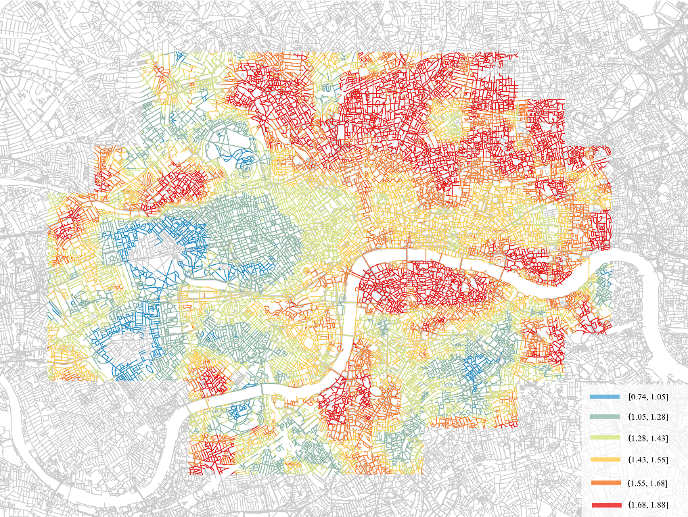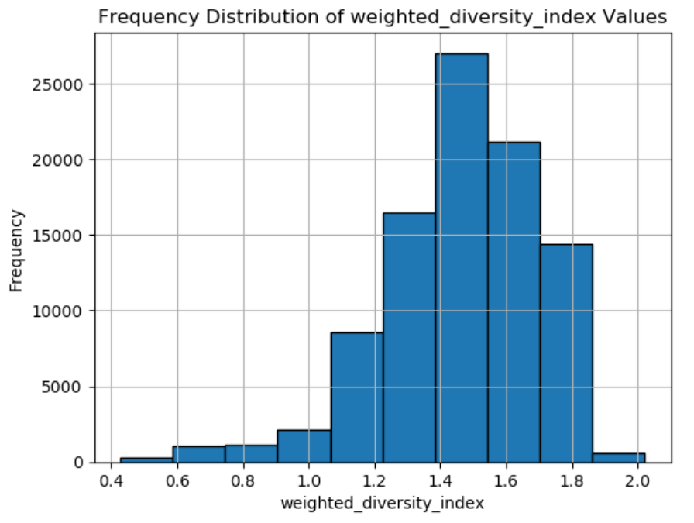

The perceived quality score map (**Figure 4.4**, left) does not exhibit a clear pattern, with high and low-quality streets being highly mixed. The frequency distribution of values indicates that the vast majority of perceived quality scores fall within the 0.45-0.6 range (**Figure 4.4**, right), suggesting that the CAZ is relatively balanced in terms of street quality, with no significant regional differences. However, when the street perceived quality is aggregated to the 1km grid and LSOA levels, different patterns may emerge. Subsequent regression analyses will involve modeling and analysis at both levels to explore potential relations.

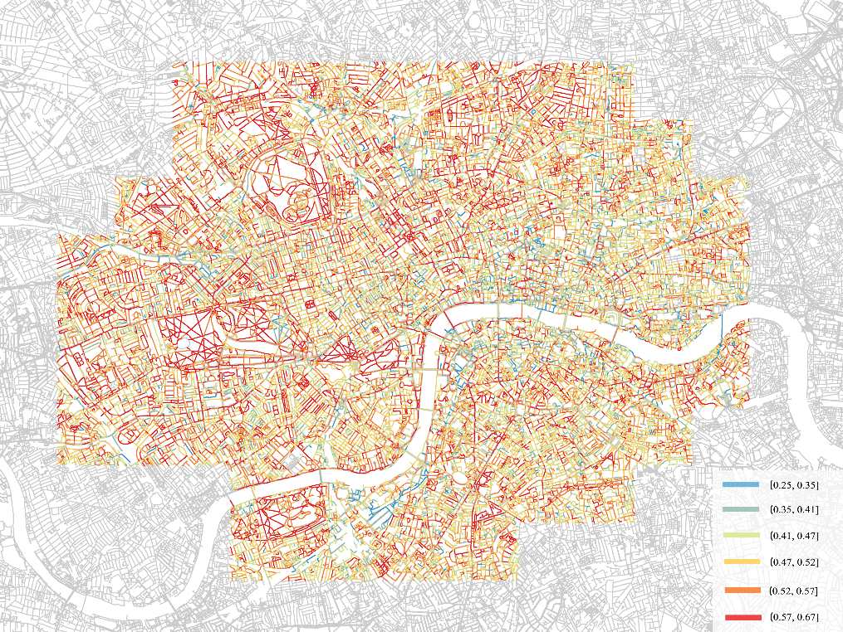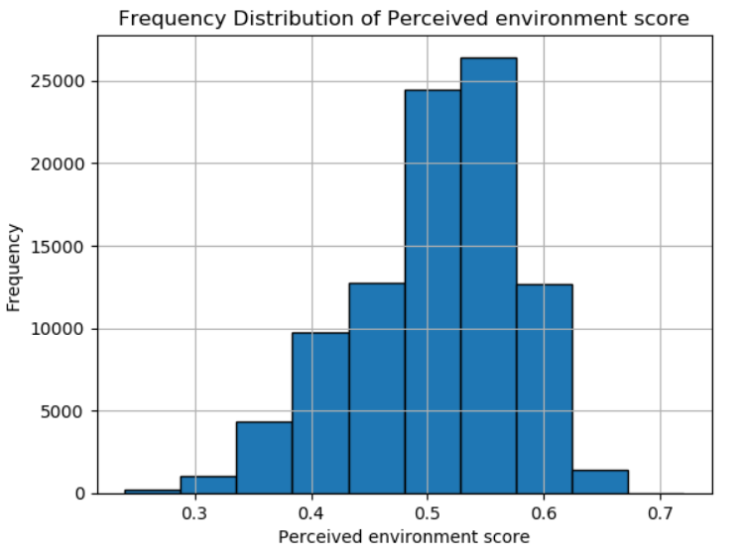

**Figure 4. 4**: Perceived quality pattern in London CAZ (left), histogram of perceived quality score (rgiht)

Overall, the HSA map (**Figure 4.1**) represents the distribution trend of the 15-minute city level in London's CAZ. This pattern generally aligns with our common sense, as affluent areas such as Westminster, City of London, and Soho have higher HSA values. Based on this pattern, we expect that housing prices, regional economic levels, and other factors may also be related to HSA levels. Additionally, although WDI and perceived quality are both indicators used to calculate HSA, their patterns are quite different. This suggests that the formation of HSA geographical differences may be primarily influenced by factors such as the number, weight, and distance of POIs.

## 4.2 Regression Analysis

### 4.2.1 Global: GLM

* + - 1. *Transport Emission Indicator*

The GLM modeling (**Figure 4.5**) for the three 15-minute city indicators and the four transport emission indicators show that no significant linear relationships (p-value < 0.05) between them. We also attempted to remodel the data by transformed forms, yielding the same results. We observed an overall trend in the p-values of different indicators: WDI (around 0.13) < HAS (around 0.35) < perceived quality (around 0.6). This overall significant difference suggests that WDI is more likely to have an underlying linear relationship with transport emission indicators compared to the others, potentially requiring an expanded sample size or reduced scale to capture this relationship.

In summary, there is no significant linear relationship between the 15-minute city level and transport emissions at 1km grid scale. This directly challenges the aspect of the 15-minute city theory concerning the reduction of transport emissions—why hasn't an urban environment that encourages walking reduced transport emissions? We will discuss this further in the subsequent sections.

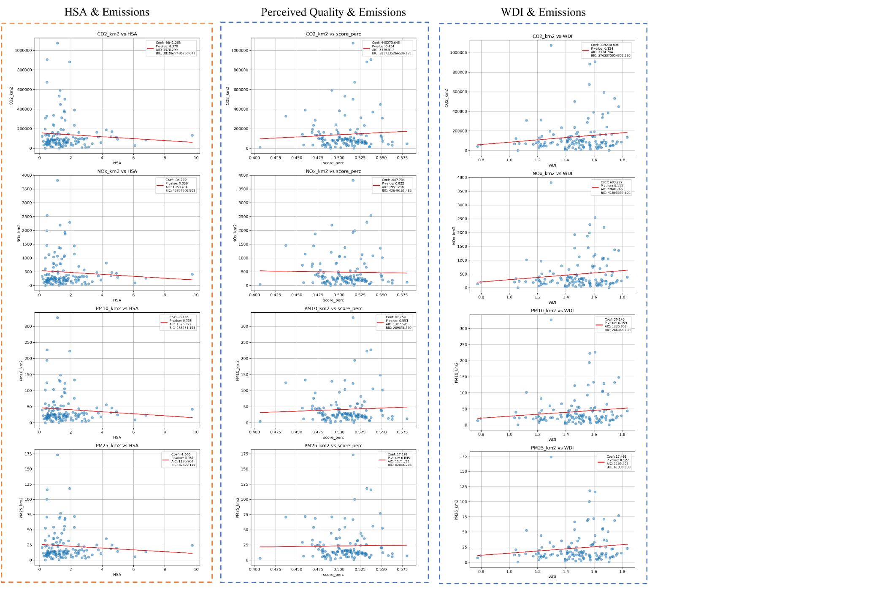

**Figure 4. 5**: GLM models of 15-minute city level and transport emissions

* + - 1. *Socio-Green Indicator*

Although the GLM method shows no significant linear relationship between the 15-minute city indicators and local transport emissions, we found a significant linear relationship (p-value < 0.05) between these indicators and local Socio-Green indicators. The **Figure 4.7** displays the coefficients and correlations for each model. Six groups of variables exhibit significant linear relationships (**Figure 4.6**, with red frameworks): HSA with Non-Car household proportion (a) and Green-Commute proportion (b); perceived quality with Non-Car household proportion (e); and WDI with Non-Car household proportion (i), Green-Commute proportion (j), Well-Health proportion (k), and Non-Deprivation household proportion (l). Among these, a), b), i) show positive correlations, and others have negative correlations. The positive effects can be explained by the 15-minute city level reducing the use of local private transportation through increased walkability and accessibility. Interpreting the negative effects requires considering more complex demographic and socio-economic 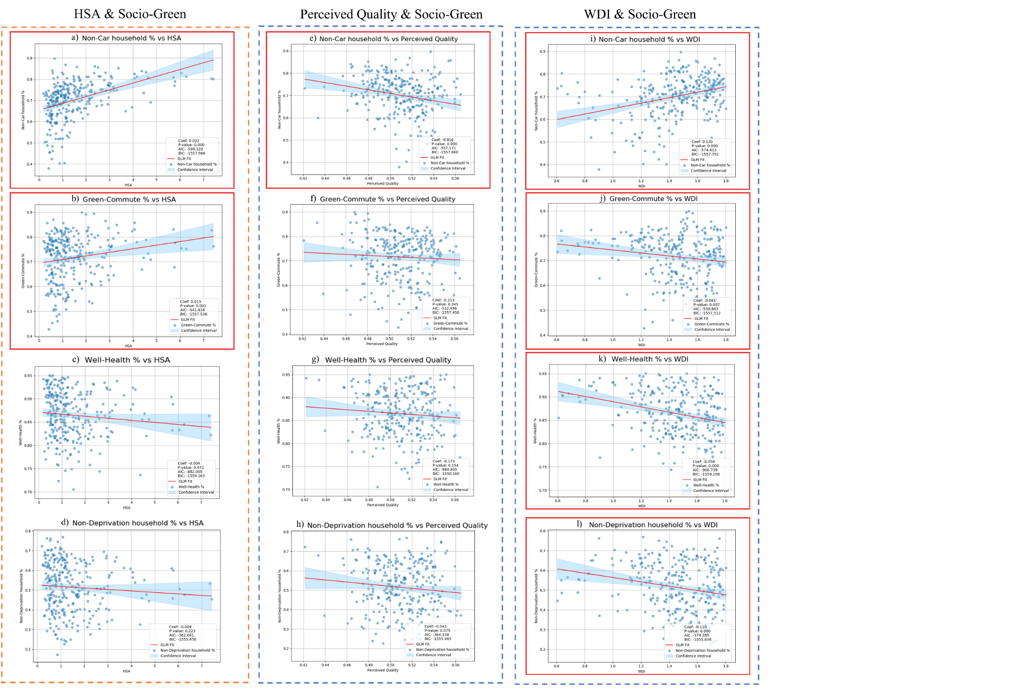backgrounds.

**Figure 4. 6**: GLM models of 15-minute city level and Socio-Green indicators. a) b) c) d) for HSA; e) f) g) h) for perceived quality; i) j) k) l) for WDI.

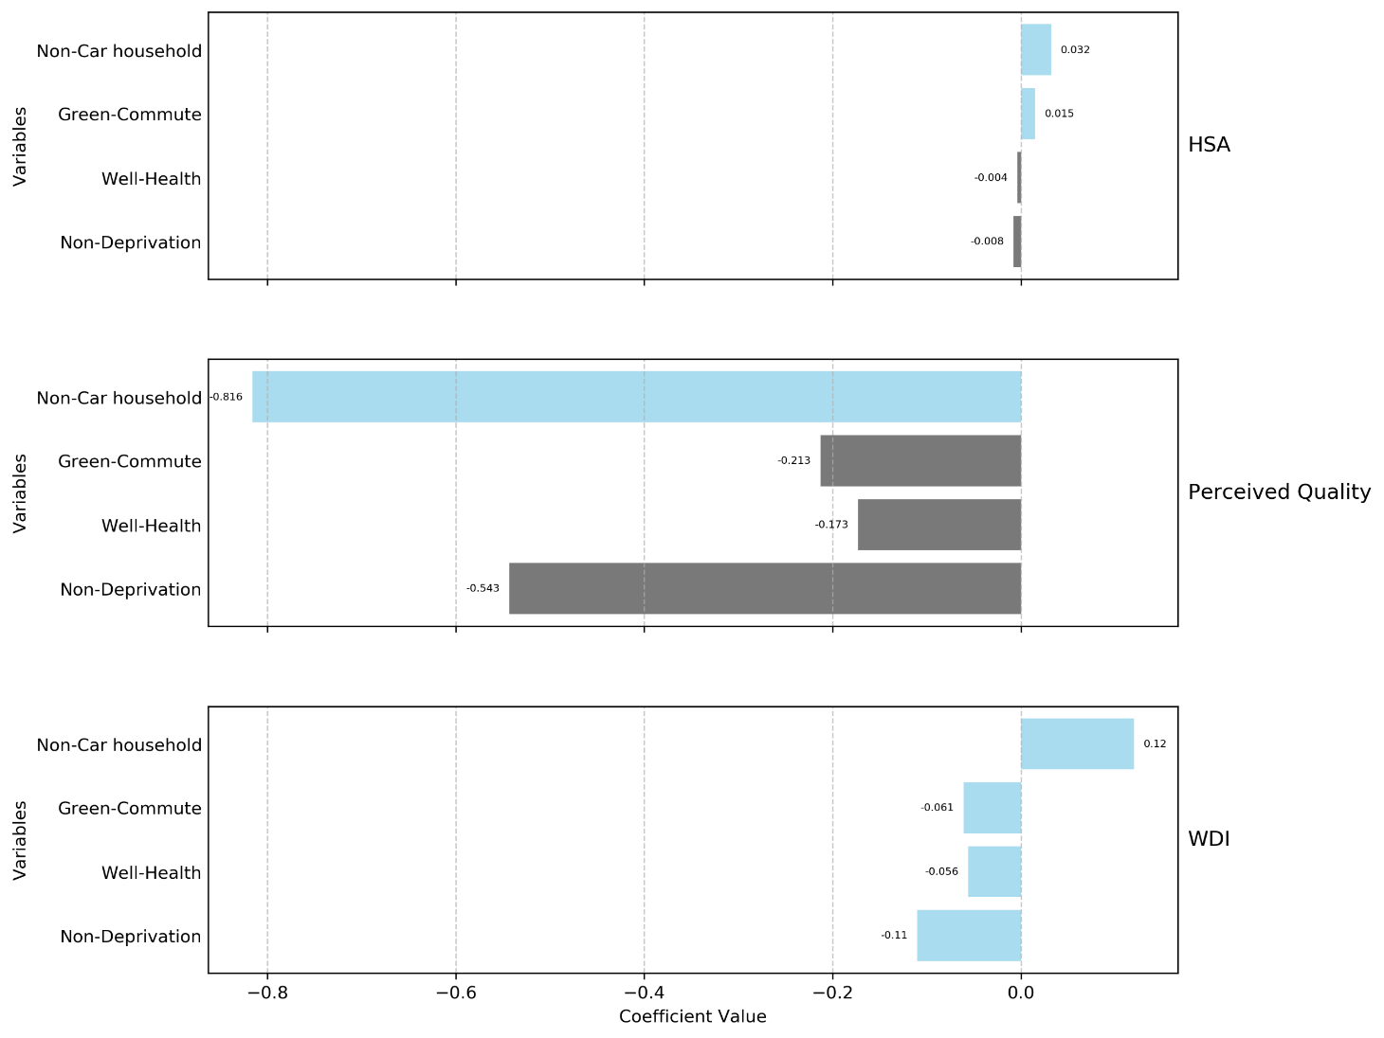

**Figure 4. 7**: The coefficients of GLM models of 15-minute city level and Socio-Green indicators.

The negative correlation between perceived environmental quality and the Non-Car household proportion can be explained by the spatial mismatch between highly perceived natural environments and urban environments for daily living. The feature importance of the LGBoost model (**Figure B.1**) shows that natural elements (plant, trees, sky, grass, etc.) have higher influences to perceived quality. This indicates that areas with high perceived quality are mostly located in open natural environments such as remote suburbs or large parks. It is well known that the rise of private cars to some extent serves the need for suburban households to commute quickly to city centers (Ewing & Cervero, 2010). Therefore, the negative correlation between perceived quality and Non-Car household proportion can be explained as follows: the higher the perceived quality of an area, the more likely it is to be located in the suburbs, and households in these areas are more inclined to own private cars due to daily commuting needs (Boulange et al., 2017).

The negative relationships between local WDI and green commuting, health status, and the Non-Deprivation household proportion have more complex causes. Areas with high POI diversity often represent bustling areas, such as regional activity centers, with complex road traffic and high population density. Central areas have more public transport stops but may also face more severe traffic congestion and safety hazards. High public transport accessibility and low safety perception inhibit local residents' willingness to walk and cycle. Regarding Well-Health proportion, due to the crowding and traffic congestion caused by high-density populations, these areas are more likely to have higher environmental pollution and mental stress which cause negative to health. Additionally, diverse POIs may expose people to more unhealthy activities, such as fast food and drinking, which can also lead to health risks (Burgoine et al., 2018). The negative correlation between WDI and Non-Deprivation household proportion can be explained by the tendency for urban poverty concentration caused by socio-economic stratification and job-housing separation (Hochstenbach & Musterd, 2018). Due to factors such as crowding, pollution, and noise, affluent households may prefer to obtain better housing in suburbs and wealthy communities. Poor households, struggling to afford daily commuting costs, are more inclined to live in highly convenient communities. Research shows that 15-minute cities lead to higher perceived segregation (Abbiasov et al., 2024), with the wealthy tending to engage in daily activities across districts while low-income families tend to be active locally. Therefore, low-income households are more likely than affluent households to choose to live in areas with high WDI.

### 4.2.2 Local: GWR

The local models control the spatial scale using “neighbors” parameter, with 26-154 neighbors (specific values tested using segmented search method) and adaptive bi-square fitting. The global and local model results for each pair of variables are shown in **Table 4.1**. AICc (Akaike Information Criterion corrected) is a measure of information loss, with models having lower AICc values being preferred. The AICc values for both global and local models are negative, indicating that both types of models have very high goodness of fit, with small residual sum of squares (RSS) and a very large number of observations relative to the number of model parameters. Overall, the AICc values of the local models are smaller than those of the global models, and the GWR local models clearly outperform the GLM global models in terms of goodness of fit and explanatory power. By considering spatial heterogeneity, GWR local models provide more accurate and explanatory results in most cases. The models of HSA and perceived quality have better R2 performance (around 0.5), indicating good 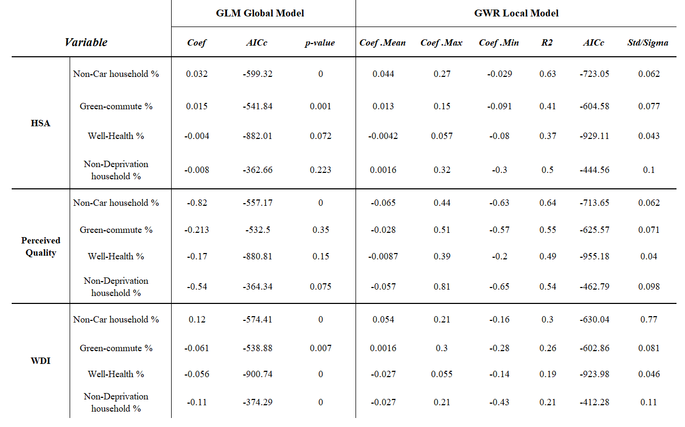explanatory power.

**Table 4. 1**: Regression results in the global model (General Linear regression) and the local model (GWR)

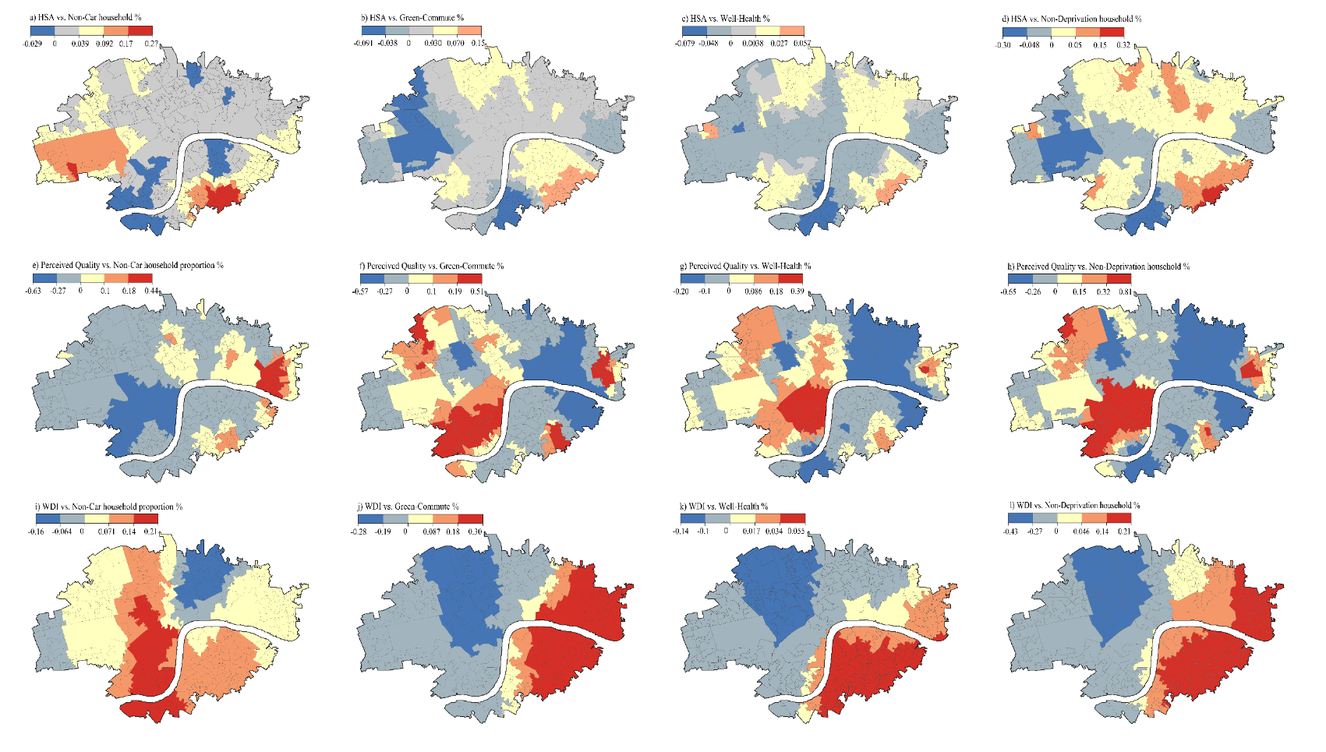The GWR coefficient maps (**Figure 4.8**) show the spatial heterogeneity of factor influences. There are large-scale regional differences in the relationships between 15-minute city level and Socio-Green indicators that global models cannot capture. For example, the global model shows a positive correlation between HSA and Non-Car household proportion, while the GWR model shows that the positive correlation is more prominent in the southeast and west, with some areas showing a negative correlation. Similarly, the negative correlation between perceived environment and Non-Car household proportion mainly occurs in the western region and is very prominent in the central-west, while some areas in the east and south show a prominent positive correlation. Furthermore, in the WDI models, this east-west geographical difference is more obvious, causing completely opposite theories may apply in different areas. Local models provide a more precise geographical differentiation perspective for global models, helping to develop more targeted regionalized policies.

**Figure 4. 8**: Spatial distribution of coefficients of the local regression factors from the GWR models. a) b) c) d) for HSA; e) f) g) h) for perceived quality; i) j) k) l) for WDI

# Discussion & Conclusion

In the context of the 15-minute city planning strategy, we aimed to further understand its ability to promote the reduction of transport emissions and its relationship with residents' travel behavior, health, and economics. In particular, we sought to measure the extent of geographical variation in these relationships. We integrated new data (such as OSM and street-view data) and traditional data (such as census data) to establish a new indicator, called "Human-Scale Accessibility", to quantify the 15-minute city level at street scale and performed global and local modeling of the relationships between them.

Our research found that the 15-minute city level does not directly promote the reduction of transport emissions in the London CAZ area but significantly promotes a local residents' low-pollution, healthy lifestyle (Socio-Green lifestyle). These findings directly challenge the aspect of the 15-minute city theory concerning the reduction of transport emissions. However, we believe that this non-correlation is due to the specificity of the London CAZ itself, and the positive relationship between the 15-minute city and Socio-Green lifestyle still proves its positive significance for reducing transport emissions. The results indicate that the relationships between the three 15-minute city indicators and Socio-Green indicators exhibit considerable geographical differences at the LSOA level, mainly manifested in the differences between the eastern and western regions.

Theoretically, 15-minute cities encourage daily non-motorized travel by creating high-density, diverse, and highly walkable environments, reducing the local use of private cars and, consequently, transport emissions (Moreno et al., 2021). This theory's logic is so clear that it has almost become a self-evident axiom. Therefore, this study aims to test this conclusion by quantifying the 15-minute city level. The results prompt us to consider the following logic: generally, transport emissions may not primarily originate from the residents of area itself. HSA is indicator evaluate 15-minute city level through land use, urban environment etc. but there is no evidence show its influence must happen locally. As Yang (2023) suggests that built environment factors has complicated and non-linear impact to CO2 emission. In this study, there are two potential reasons for this: First, the mobility of private cars leads to the non-local nature of emissions. Regional transport emissions accumulate due to the number of motor vehicles and the degree of congestion (Barth & Boriboonsomsin, 2008; Zhang & Batterman, 2013). The destinations of private cars are generally urban centers or sub-centers, with emissions from surrounding cars concentrating heavily in central urban areas rather than in residential areas. Second, the CAZ is the center of London which at a special situation. It undertakes a large amount of external traffic and public transport flow, resulting in a significant amount of noise in the data that exceeds the robustness of the model itself. The goal of 15-minute cities is to influence the behavior of local residents, but external traffic flows are influenced by broader factors such as urban functions and polycentricity (Cabrera-Arnau et al., 2023), which are beyond the explanatory scope of this model. Therefore, we can infer that local transport emissions are not directly associated with local 15-minute cities at macro scale, especially in large central urban areas with substantial external traffic flows, where this association is even more tenuous. This is one of the main findings of this study: the actual effects of 15-minute cities cannot be simply measured by local transport emissions; rather, the focus should be on their impact on the behavior of local residents themselves.

Socio-Green indicators represent the behavior and socio-economic status of local residents at the LSOA level. Their GLM modeling results demonstrate the impact of the spatial structure shaped by the 15-minute city theory on people's lifestyles. Socio-spatial dialectic (Soja, 1980) posits that space is ultimately influenced by ideology and politics; it has always been political and strategic. Soja further extend it to ThirdSpace theory (1998) which indicates the third space, defined by the combination of urban spatial structure (First Space) and public imagination (Second Space), is a way of life. This lifestyle is viewed by Jacobs (1961) as the "soul" of a city. It depicts the basic logic of how 15-minute city functions: the purpose of 15-minute cities is precisely to guide people to pursue an ideal lifestyle (Third Space) by defining the first physical space. Consequently, the spatial structure of high HSA successfully reduces household car ownership and encourages walking or cycling for commuting. This relationship indicates the positive significance of the 15-minute city structure in promoting health and sustainable travel (Cheng et al., 2019; Khreis et al., 2016), and it remains a valuable theoretical model for sustainable development.

This study highlights another conclusion: it clarifies some of the impacts of the 15-minute city concept on the lifestyles of local residents. Although the 15-minute city emphasizes multi-stakeholder participation and gradual, moderate updates, its underlying logic of defining spaces and lifestyles in a top-down manner has raised concerns about its practical efficiency and potential to cause social segregation. Abbiasov et al. (2024) found that even in high-density U.S. cities like New York and Detroit—the most conducive to implementing the 15-minute city—most residents' daily activities do not occur locally, with a 15-minute usage rate of only 14%, and higher-income groups utilizing local facilities even less. This reveals a deeper complexity: due to lifestyle changes and reduced transportation costs, people may prefer high-quality, clustered consumption and engage in cross-district activities even when local facilities are well-established. Moreover, the 15-minute city's aim to localize residents' daily activities may lead to regional isolation. Abbiasov et al. (2024) suggest that the isolation effects produced by the 15-minute city are unfriendly to low-income groups, potentially exacerbating their social isolation tendencies, undermining sustainable development, and hindering social equity. The gap between the theoretical model and practice, viewed from the perspectives of actual efficiency and social isolation, further challenges the underlying logic of the 15-minute city's theory of reducing transportation emissions. Future research should consider the relationship between the spatial structure of the 15-minute city and its actual usage, exploring the principles and quantifying the efficiency of its emission reduction.

The local models reveal the geographical heterogeneity of the influence factors. Referring the map of inner London neighbours (**Figure 5.1**) with GWR coefficient maps (**Figure 4.8**), we found that relationship between the three 15-minute city and the Socio-Green indicators varies across neighbours in CAZ. For instance, while HSA promotes the Non-Car household proportion in most neighborhoods, it has a negative effect in parts of Westminster and South Bank. This may relate to the local context and positioning: Westminster as a renowned wealthy area and the center of British politics, business, and culture, has the highest Gross Value Added (GVA) among London's boroughs and persistently high housing prices. Local households in Westminster have superior economic conditions and a strong ability to afford private transportation. Thus, despite high 15-minute city levels, households here are more inclined to purchase vehicles. Other Socio-Green indicators exhibit similar patterns, with negative relationships in the southern (Lambeth) and western (Paddington) regions. In the western region, urban functions are separated by large green spaces of Hyde Park, making the 15-minute city theory less applicable and become potential reason of the negative relationship. Lambeth, in the south, has a higher deprivation rate and evident job-housing separation and gentrification. As the junction between the central area and the high deprived southern regions, it has housing prices lower than the London average (UHPI, 2023; Lambeth Council, 2022), attracting a large number of commuting working-class individuals from outside the area. Their primary activity areas are not within their residential areas, potentially leading to a lack of local living patterns and the ineffectiveness of the 15-minute city initiative, resulting in this negative relationship.

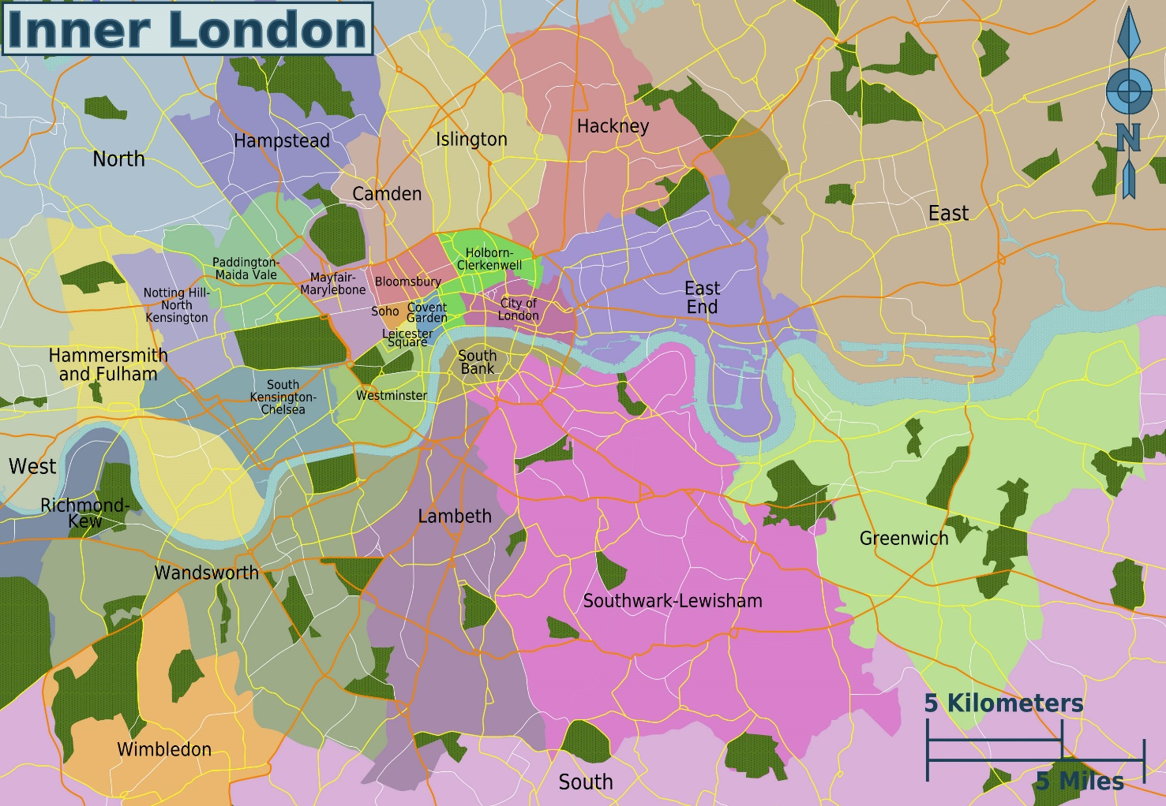

**Figure 5. 1**: The neighbours of Inner London

When attempting to translate research findings into policy measures, it is crucial to focus on the geographical heterogeneity exhibited by specific areas. The western region of the CAZ (including Hyde Park), the Westminster, the East End, and the northern part of Lambeth display varying degrees of variability in their response to HSA levels and Socio-Green indicators, making them key areas for policy attention. We propose **five general policy directions** based on our findings to support the implementation of the 15-minute city strategy in London CAZ. However, it is important to acknowledge the limitations of context-specific research; these recommendations should not be considered mandatory requirements. Instead, when formulating plans, it is necessary to review the context to avoid potential risks associated with universal thinking.

1. To reduce transport emissions in CAZ, focus should be placed on traffic control and restriction measures for external vehicles to decrease traffic volume and road congestion. For example, encourage the use of new energy vehicles and implement time-based traffic management.
2. Acknowledge regional particularities and implement differentiated 15-minute city strategies. For Westminster and its surrounding areas, further optimizing environmental quality will yield better socio-economic outcomes. In the eastern and southern regions, focus on increasing the density, diversity, and quality of POIs and encouraging the development of small and medium-sized service enterprises, which will greatly enhance local well-being.
3. Adopt combined measures to mitigate the risk of socio-economic segregation that may arise from the 15-minute city initiative. For example, in gentrified neighborhoods such as northern Lambeth and Westminster, increase support for social housing and affordable housing, improve the multi-level housing security system, enhance community public service facilities, and implement education and medical subsidies.
4. Improve the evaluation and monitoring mechanisms for the 15-minute city. Avoid blindly pursuing high-density POIs and environmental quality improvements; instead, conduct in-depth analysis of background factors in conjunction with surveys on actual 15-minute usage by local residents.
5. Strengthen regional coordination in the development of the 15-minute city. In practice, the construction of 15-minute city cannot be isolated from the larger-scale regional context. Therefore, it is necessary to establish a multi-sectoral and multi-stakeholder collaborative development mechanism. Fully mobilize the participation and enthusiasm of local residents. Guide reasonable investment of social capital through planned government investment to achieve sustainable development.

In summary, our research establishes the "HSA" indicator to quantify the spatial structure of 15-minute city and explores its relationship with transportation emissions and spatial structure of urban activities. Firstly, we demonstrate the relationship between the 15-minute city level and transport emissions in London CAZ. Secondly, we provide evidence of the actual impact of the 15-minute city on local lifestyles, supporting differentiated development policies. The main contribution of this study is the development of a street-level quantitative indicator for the 15-minute city. This indicator is the first to comprehensively incorporate environmental perception, POI accessibility and diversity, and it is also the first indicator at street-level. This indicator has the potential to be applied in various quantitative analysis scenarios for the 15-minute city, supporting fine-grained research on urban activity spatial structures.

# Limitation & Future Research

Due to data accessibility and computational capacity, this study has some limitations. Firstly, the transport emission and census data released by the GLA and ONS was collected in 2019 and 2021 while the other data (street-view image, road network, and POI data) are the latest from 2024. This may cause influences to results. Secondly, the POI category weights were manually evaluated by the author based on the share of travel purpose (TFL, 2011). Ideally, an expert panel should estimate the weights for each category to ensure a more objective and reliable assessment. Thirdly, limited by computational capacity of machine, this study indirectly calculates network distances using the circuity factor and Euclidean distances, which may deviate from actual network distances and affect the HSA results. Lastly, machine learning models cannot fully explain human perception patterns of the environment. Perception is a subjective judgment that may be influenced by personal preferences, culture, memory, and other physical factors. The perceptual assessment by machine learning only involves visual patterns; therefore, it will inevitably produce deviations from the actual perceived quality of the environment.

Finally, we outline six main directions for future work: First, further optimize the HSA model. For example, using expert panel to assess POI category weights, resolving computational issues to calculate actual network distances, employing advanced algorithms to improve the predictive model for perceived quality, calculating exponential parameters for variables to balance their impact weights, and adding other relevant variables; Second, use HSA model to explore the possibilities of the 15-minute city in other potential areas, as it has been shown to be associated with urban vitality, mobility, socio-economic segregation, and happiness; Third, combine HSA with new data at a finer scale (e.g., mobile phone data) to explore correlations with urban characteristics at a more granular level; Fourth, flexibly adjust the POI categories included in model according to research purposes and develop HSA models for specific activity types (such as “educational HSA”, “entertaining HSA”); Fifth, extend the HSA model to the cycling dimension to measure the 15-minute city level under the cycling mode, which may involve expanding the catchment range and modeling environmental perception at the cycling scale; Sixth, Consider the deeper social and spatial structural factors that lead to the discrepancy between the 15-minute city theory and actual usage, and explore the relationship between actual 15-minute usage and transportation emissions.

# Bibliography

Abbiasov, T., Heine, C., Sabouri, S., Salazar-Miranda, A., Santi, P., Glaeser, E., & Ratti, C. (2024). ‘The 15-minute city quantified using human mobility data’, *Nature Human Behaviour*, *8*(3), 445-455.

Adkins, A., Dill, J., Luhr, G., & Neal, M. (2012). ‘Unpacking walkability: Testing the influence of urban design features on perceptions of walking environment attractiveness’, *Journal of Urban Design*, 17(4), 499-510.

Alfonzo, M. A. (2005). ‘To walk or not to walk? The hierarchy of walking needs’, *Environment and behavior*, 37(6), 808-836.

Allam, Z. (2019). ‘Achieving neuroplasticity in artificial neural networks through smart cities’, *Smart Cities*, 2(2), 118-134.

Allam, Z., & Jones, D. (2019). ‘Climate change and economic resilience through urban and cultural heritage: The case of emerging small island developing states economies’, *Economies*, 7(2), 62.

Allam, Z., Bibri, S. E., Chabaud, D., & Moreno, C. (2022). ‘The ‘15-Minute City’concept can shape a net-zero urban future’, *Humanities and Social Sciences Communications*, 9(1), 1-5.

Allam, Z., Bibri, S. E., Chabaud, D., & Moreno, C. (2022). ‘The theoretical, practical, and technological foundations of the 15-minute city model: proximity and its environmental, social and economic benefits for sustainability’, *Energies*, 15(16), 6042.

Allam, Z., Bibri, S. E., Jones, D. S., Chabaud, D., & Moreno, C. (2022). ‘Unpacking the ‘15-minute city’via 6G, IoT, and digital twins: Towards a new narrative for increasing urban efficiency, resilience, and sustainability’, *Sensors*, 22(4), 1369.

Allam, Z., Jones, D., & Thondoo, M. (2020). ‘Cities and climate change: Climate policy, economic resilience and urban sustainability’, *Springer Nature*.

Barth, M., & Boriboonsomsin, K. (2008). ‘Real-world carbon dioxide impacts of traffic congestion’, *Transportation research record*, 2058(1), 163-171.

Bartzokas-Tsiompras, A., Tampouraki, E. M., & Photis, Y. N. (2020). ‘Is walkability equally distributed among downtowners? Evaluating the pedestrian streetscapes of eight European capitals using a micro-scale audit approach’, *City Sustain. Regen*, *4*, 75-92.

Bassolas, A., Barbosa-Filho, H., Dickinson, B., Dotiwalla, X., Eastham, P., Gallotti, R., ... & Ramasco, J. J. (2019). ‘Hierarchical organization of urban mobility and its connection with city livability’, *Nature communications*, *10*(1), 4817.

Blečić, I., Cecchini, A., & Trunfio, G. A. (2018). ‘Towards automatic assessment of perceived walkability’, In *Computational Science and Its Applications–ICCSA 2018: 18th International Conference, Melbourne, VIC, Australia, July 2–5, 2018, Proceedings, Part III 18* (pp. 351-365). Springer International Publishing.

Boulange, C., Gunn, L., Giles-Corti, B., Mavoa, S., Pettit, C., & Badland, H. (2017). ‘Examining associations between urban design attributes and transport mode choice for walking, cycling, public transport and private motor vehicle trips’, *Journal of Transport & Health*, 6, 155-166.

Brunsdon, C., Fotheringham, A. S., & Charlton, M. E. (1996). ‘Geographically weighted regression: a method for exploring spatial nonstationarity’, *Geographical analysis*, 28(4), 281-298.

Brunsdon, C., Fotheringham, S., & Charlton, M. (1998). ‘Geographically weighted regression’, *Journal of the Royal Statistical Society: Series D (The Statistician)*, 47(3), 431-443.

Burgoine, T., Sarkar, C., Webster, C. J., & Monsivais, P. (2018). ‘Examining the interaction of fast-food outlet exposure and income on diet and obesity: evidence from 51,361 UK Biobank participants’, *International Journal of Behavioral Nutrition and Physical Activity*, *15*, 1-12.

Cervero, R., & Kockelman, K. (1997). ‘Travel demand and the 3Ds: Density, diversity, and design’, *Transportation research part D: Transport and environment*, *2*(3), 199-219.

Cheng, L., Chen, X., Yang, S., Cao, Z., De Vos, J., & Witlox, F. (2019). ‘Active travel for active ageing in China: The role of built environment’, *Journal of Transport Geography*, 76, 142-152.

Comber, A., Brunsdon, C., Charlton, M., Dong, G., Harris, R., Lu, B., ... & Harris, P. (2020). ‘The GWR route map: a guide to the informed application of Geographically Weighted Regression’, arXiv preprint arXiv:2004.06070.

Cranshaw, J., Schwartz, R., Hong, J., & Sadeh, N. (2012). ‘The livehoods project: Utilizing social media to understand the dynamics of a city’, In *Proceedings of the international AAAI conference on web and social media* (Vol. 6, No. 1, pp. 58-65).

Cubukcu, K.M. (2021). ‘Using circuity as a network efficiency measure: the example of Paris’, *Spatial Information Researc*h, 29(2), pp. 163–172.

Dong, R., Zhang, Y., & Zhao, J. (2018). ‘How green are the streets within the sixth ring road of Beijing? An analysis based on tencent street view pictures and the green view index’, *International journal of environmental research and public health*, *15*(7), 1367.

El-Geneidy, A. M., & Levinson, D. M. (2006). ‘Access to destinations: Development of accessibility measures’.

Ewing, R., & Cervero, R. (2001). ‘Travel and the built environment: a synthesis’, *Transportation research record*, *1780*(1), 87-114.

Ewing, R., & Cervero, R. (2010). ‘Travel and the built environment: A meta-analysis’, *Journal of the American planning association*, *76*(3), 265-294.

Ewing, R., & Handy, S. (2009). ‘Measuring the unmeasurable: Urban design qualities related to walkability’, *Journal of Urban design*, 14(1), 65-84.

Frank, L. D., & Pivo, G. (1994). ‘Impacts of mixed use and density on utilization of three modes of travel: single-occupant vehicle, transit, and walking’, *Transportation research record*, *1466*, 44-52.

Frank, L. D., Sallis, J. F., Conway, T. L., Chapman, J. E., Saelens, B. E., & Bachman, W. (2006). ‘Many pathways from land use to health: associations between neighborhood walkability and active transportation, body mass index, and air quality’, *Journal of the American planning Association*, *72*(1), 75-87.

Gehl, J. (2011). *Life between buildings (6th ed.)*. Island Press.

Gehl, J. (2010). *Cities for People*. Island Press.

Geurs, K. T., & van Wee, B. (2004). ‘Accessibility evaluation of land-use and transport strategies: review and research directions’, *Journal of Transport Geography*, 12(2), 127-140.

Giacomin, D.J. and Levinson, D.M. (2015) ‘Road network circuity in metropolitan areas’, *Environment and Planning B: Planning and Design*, 42(6), pp. 1040–1053.

Gidlow, C.J., Ellis, N.J., & Bostock, S. (2012) ‘Development of the neighbourhood green space tool (NGST)’, *Landscape and Urban Planning*, 106(4), pp. 347-358.

Graells-Garrido, E., Serra-Burriel, F., Rowe, F., Cucchietti, F. M., & Reyes, P. (2021). ‘A city of cities: Measuring how 15-minutes urban accessibility shapes human mobility in Barcelona’, *PloS one*, *16*(5), e0250080.

Greater London Authority (GLA) (2016). ‘Central Activities Zone supplementary planning guidance’, *Greater London Authority*. Available online: <https://www.london.gov.uk/sites/default/files/caz_spg_final_v4.pdf> (accessed on 15 June 2024).

Greater London Authority (GLA) (2021). ‘The London Plan 2021’, *Greater London Authority*. Available online: <https://www.london.gov.uk/sites/default/files/the_london_plan_2021.pdf> (accessed on 15 June 2024).

Handy, S. L., & Niemeier, D. A. (1997). ‘Measuring accessibility: an exploration of issues and alternatives’, *Environment and planning A*, 29(7), 1175-1194.

Handy, S., & Clifton, K. (2001). ‘Local shopping as a strategy for reducing automobile travel’, *Transportation*, 28(4), 317-346.

Hansen, W. G. (1959). ‘How accessibility shapes land use’, *Journal of the American Institute of planners*, *25*(2), 73-76.

Hastie, T. J., & Pregibon, D. (2017). *Generalized linear models*, ‘In Statistical models in S’ (pp. 195-247). Routledge.

Hastie, T., Tibshirani, R., Friedman, J., & Franklin, J. (2005). ‘The elements of statistical learning: data mining, inference and prediction’, *The Mathematical Intelligencer*, *27*(2), 83-85.

Hawkins, D. M. (2004). ‘The problem of overfitting’, *Journal of chemical information and computer sciences*, 44(1), 1-12.

Hochstenbach, C., & Musterd, S. (2018). ‘Gentrification and the suburbanization of poverty: Changing urban geographies through boom and bust periods’, *Urban geography*, *39*(1), 26-53.

Huang, J. and Levinson, D.M. (2015) ‘Circuity in urban transit networks’, *Journal of Transport Geography*, 48, pp. 145–153.

Huff, D. L. (1963). ‘A probabilistic analysis of shopping center trade areas’, *Land economics*, *39*(1), 81-90.

Ingram, D. R. (1971). ‘The concept of accessibility: A search for an operational form’, *Regional studies*, *5*(2), 101-107.

Jacobs, J. (1961). *The Death and Life of Great American Cities.* New York: Random House.

James, G., Witten, D., Hastie, T., & Tibshirani, R. (2013). *An introduction to statistical learning (Vol. 112, p. 18)*. New York: springer.

Kaza, N. (2013). ‘The changing urban landscape of the continental United States’, *Landscape and Urban Planning*, 110, 74-86.

Kelly, C. E., Tight, M. R., Hodgson, F. C., & Page, M. W. (2011). ‘A comparison of three methods for assessing the walkability of the pedestrian environment’, *Journal of Transport Geography*, 19(6), 1500-1508.

Khavarian-Garmsir, A. R., Sharifi, A., & Sadeghi, A. (2023). ‘The 15-minute city: Urban planning and design efforts toward creating sustainable neighborhoods’, *Cities*, 132, 104101.

Khreis, H., Warsow, K. M., Verlinghieri, E., Guzman, A., Pellecuer, L., Ferreira, A., ... & Nieuwenhuijsen, M. (2016). ‘The health impacts of traffic-related exposures in urban areas: Understanding real effects, underlying driving forces and co-producing future directions’, *Journal of Transport & Health*, 3(3), 249-267.

Kwan, M. P. (1998). ‘Space‐time and integral measures of individual accessibility: a comparative analysis using a point‐based framework’, *Geographical analysis*, *30*(3), 191-216.

Lamb, W. F., Wiedmann, T., Pongratz, J., Andrew, R., Crippa, M., Olivier, J. G., ... & Minx, J. (2021). ‘A review of trends and drivers of greenhouse gas emissions by sector from 1990 to 2018’, *Environmental research letters*, 16(7), 073005.

Lambeth Council. (2021). *Lambeth Local Plan*.

Leslie, E., & Cerin, E. (2008) ‘Are perceptions of the local environment related to neighbourhood satisfaction and mental health in adults?’, *Preventive Medicine*, 47(3), pp. 273-278.

Leung, Y., Mei, C. L., & Zhang, W. X. (2000). ‘Statistical tests for spatial nonstationarity based on the geographically weighted regression model’, *Environment and Planning A*, 32(1), 9-32.

Levinson, D. and El-Geneidy, A. (2009) ‘The minimum circuity frontier and the journey to work’, *Regional Science and Urban Economics*, 39(6), pp. 732–738.

Levinson, D. M., & Kumar, A. (1994). ‘A multi-modal trip distribution model’, *Transportation Research Record*, *1466*, 124-131.

Levinson, D., & Krizek, K. J. (2008). *Planning for Place and Plexus: Metropolitan Land Use and Transport*. Routledge.

Li, S., Chen, P., Hui, F., & Gong, M. (2024). ‘Evaluating urban vitality and resilience under the influence of the COVID-19 pandemic from a mobility perspective: A case study in Shenzhen, China’, *Journal of Transport Geography*, *117*, 103886.

Li, Y., & Yeh, A. G. (2004). ‘Analyzing spatial restructuring of land use patterns in a fast growing region using remote sensing and GIS’, *Landscape and Urban Planning*, 69(4), 335-354.

Li, Z., & Long, Y. (2019). ‘Analysis of the variation in quality of street space in shrinking cities based on dynamic street view picture recognition: A case study of Qiqihar’, *Shrinking cities in China: The other facet of urbanization*, 141-155.

Litman, T. (2017). *Evaluating accessibility for transport planning*. Victoria, BC, Canada: Victoria Transport Policy Institute.

Liu, M., Han, L., Xiong, S., Qing, L., Ji, H., & Peng, Y. (2019). ‘Large-scale street space quality evaluation based on deep learning over street view image’, In *Image and Graphics: 10th International Conference, ICIG 2019, Beijing, China, August 23–25, 2019, Proceedings, Part II 10* (pp. 690-701). Springer International Publishing.

Logan, T. M., Hobbs, M. H., Conrow, L. C., Reid, N. L., Young, R. A., & Anderson, M. J. (2022). ‘The x-minute city: Measuring the 10, 15, 20-minute city and an evaluation of its use for sustainable urban design’, *Cities*, 131, 103924.

Long, J., Shelhamer, E. and Darrell, T. (2015) ‘Fully Convolutional Networks for Semantic Segmentation’, in. *Proceedings of the IEEE Conference on Computer Vision and Pattern Recognition*, pp. 3431–3440.

Magurran, A. E. (2004). *Measuring Biological Diversity*. Blackwell Science Ltd.

Magurran, A. E. (2021). ‘Measuring biological diversity’, *Current Biology*, *31*(19), R1174-R1177.

Manaugh, K., & El-Geneidy, A. M. (2012). ‘Who benefits from new transportation infrastructure? Using accessibility measures to evaluate social equity in transit provision’, *Accessibility and Social Equity in Transit Provision*, 20(1), 95-102.

Manaugh, K., & Kreider, T. (2013). ‘What is mixed use? Presenting an interaction method for measuring land use mix’, *Journal of Transport and Land use*, *6*(1), 63-72.

Maria Kockelman, K. (1997). ‘Travel behavior as function of accessibility, land use mixing, and land use balance: evidence from San Francisco Bay Area’, *Transportation research record*, *1607*(1), 116-125.

Mehta, V. (2008). ‘Walkable streets: pedestrian behavior, perceptions and attitudes’, *Journal of Urbanism*, 1(3), 217-245.

Moreno, C., Allam, Z., Chabaud, D., Gall, C., & Pratlong, F. (2021). ‘Introducing the "15-Minute City": Sustainability, Resilience and Place Identity in Future Post-Pandemic Cities’, *Smart Cities*, 4(1), 93-111.

Nagata, S., Nakaya, T., Hanibuchi, T., Amagasa, S., Kikuchi, H., & Inoue, S. (2020). ‘Objective scoring of streetscape walkability related to leisure walking: Statistical modeling approach with semantic segmentation of Google Street View images’, *Health & Place*, *66*, 102428.

Pozoukidou, G., & Chatziyiannaki, Z. (2021). ‘15-Minute City: Decomposing the New Urban Planning Eutopia’, *Sustainability*, 13(2), 928.

Qiu, Y., Liu, Y., Liu, Y., & Li, Z. (2019). ‘Exploring the linkage between the neighborhood environment and mental health in Guangzhou, China’, *International Journal of Environmental Research and Public Health*, 16(17), 3206.

Seto, K. C., Dhakal, S., Bigio, A., Blanco, H., Delgado, G. C., Dewar, D., ... & Ramaswami, A. (2014). *Human settlements, infrastructure and spatial planning*, in Climate Change 2014: Mitigation of Climate Change. Contribution of Working Group III to the Fifth Assessment Report of the Intergovernmental Panel on Climate Change. Cambridge University Press.

Shannon, C. E. (1948). ‘A mathematical theory of communication’, *Bell System Technical Journal*, 27(3), 379-423.

Shen, Q. (1998). ‘Spatial technologies, accessibility, and the social construction of urban space’, *Computers, environment and urban systems*, *22*(5), 447-464.

Soja, E. W. (1980). ‘The socio-spatial dialectic’, *Annals of the Association of American geographers*, 70(2), 207-225.

Soja, E. W. (1998). ‘Thirdspace: Journeys to Los Angeles and other real-and-imagined places’, *Capital & Class*, 22(1), 137-139.

Stewart, J. Q. (1947). ‘Empirical mathematical rules concerning the distribution and equilibrium of population’, *Geographical review*, *37*(3), 461-485.

Sun, B., Han, S., & Li, W. (2020). ‘Effects of the polycentric spatial structures of Chinese city regions on CO2 concentrations’, *Transportation Research Part D: Transport and Environment*, 82, 102333.

Swilling, M. (2018). ‘The weight of cities: Resource requirements of future urbanization’.

Talen, E. (2001). ‘School, community, and spatial equity: An empirical investigation of access to elementary schools in West Virginia’, *Annals of the Association of American Geographers*, *91*(3), 465-486.

Talen, E., & Koschinsky, J. (2013). ‘The walkable neighborhood: A literature review’, *International journal of sustainable land use and urban planning*, *1*(1).

Transport for London (TFL) (2011). ‘London Travel Demand Survey (LTDS)’. Available at: <https://www.clocs.org.uk/wp-content/uploads/2014/05/london-travel-demand-survey-2011.pdf> (Accessed: 14 June 2024).

UK House Price Index (UHPI). (2023). *UK House Price Index summary: March 2023*.

UN Environment Programme. ‘Goal 11: Sustainable Cities and Communities’. Available online: <https://www.unenvironment.org/explore-topics/sustainable-development-goals/why-do-sustainable-development-goals-matter/goal-11> (accessed on 15 June 2024).

UNFCCC. ‘Global Climate Action at COP 26’. Available online: <https://unfccc.int/climate-action/global-climate-action-at-cop-26> (accessed on 15 June 2024).

Un-Habitat. (2020). ‘World Cities Report 2020: The value of sustainable urbanization. UN’.

Vickerman, R. W. (1974). ‘Accessibility, attraction, and potential: a review of some concepts and their use in determining mobility’, *Environment and Planning A*, *6*(6), 675-691.

Wang, Q., Su, M., Li, R., & Ponce, P. (2019). ‘The effects of energy prices, urbanization and economic growth on energy consumption per capita in 186 countries’, *Journal of cleaner production*, 225, 1017-1032.

Wood, L., Hooper, P., Foster, S., & Bull, F. (2017). ‘Public green spaces and positive mental health–investigating the relationship between access, quantity and types of parks and mental wellbeing’, *Health & Place*, 48, pp. 63-71.

Wu, C., Peng, N., Ma, X., Li, S., & Rao, J. (2020). ‘Assessing multiscale visual appearance characteristics of neighbourhoods using geographically weighted principal component analysis in Shenzhen, China’, *Computers, Environment and Urban Systems*, *84*, 101547.

Wu, D., Gong, J., Liang, J., Sun, J., & Zhang, G. (2020). ‘Analyzing the influence of urban street greening and street buildings on summertime air pollution based on street view image data’, *ISPRS International Journal of Geo-Information*, *9*(9), 500.

Wu, H., Wang, L., Zhang, Z., & Gao, J. (2021). Analysis and optimization of 15-minute community life circle based on supply and demand matching: A case study of Shanghai. PloS one, 16(8), e0256904.

Xia, Y., Yabuki, N. and Fukuda, T. (2020). ‘Development of an urban greenery evaluation system based on deep learning and Google Street View’, in *Proceedings of the 25th International Conference on Computer-Aided Architectural Design Research in Asia (CAADRIA 2020)*, pp. 783–792.

Yang, J., Zhao, L., Mcbride, J., & Gong, P. (2009). ‘Can you see green? Assessing the visibility of urban forests in cities’, *Landscape and Urban Planning*, *91*(2), 97-104.

Yang, W. (2023). ‘The nonlinear effects of multi-scale built environments on CO2 emissions from commuting’, *Transportation Research Part D: Transport and Environment*, 118, 103736.

Yang, W., & Cao, X. (2018). ‘Examining the effects of the neighborhood built environment on CO2 emissions from different residential trip purposes: A case study in Guangzhou, China’, *Cities*, 81, 24-34.

Yang, Y., & Diez-Roux, A. V. (2012). ‘Walking distance by trip purpose and population subgroups’, *American journal of preventive medicine*, 43(1), 11-19.

Yang, Y., He, D., Gou, Z., Wang, R., Liu, Y., & Lu, Y. (2019). ‘Association between street greenery and walking behavior in older adults in Hong Kong’, *Sustainable Cities and Society*, 51, 101747.

Ye, Y., Zeng, W., Shen, Q., Zhang, X. and Lu, Y. (2019) ‘The visual quality of streets: A human-centred continuous measurement based on machine learning algorithms and street view images’, *Environment and Planning B: Urban Analytics and City Science*, 46, pp. 1439–1457.

Yin, L. (2017). ‘Street level urban design qualities for walkability: Combining 2D and 3D GIS measures’, *Computers, Environment and Urban Systems*, 64, 288-296.

Yu, A. (2023). ‘Exploring the 15-minute City: Access Sufficiency, Travel Behaviour, and Perceptions of Accessibility in the City of Toronto’ (Master's thesis, University of Toronto (Canada)).

Yuan, J., Zheng, Y., & Xie, X. (2012). ‘Discovering regions of different functions in a city using human mobility and POIs’, In *Proceedings of the 18th ACM SIGKDD international conference on Knowledge discovery and data mining* (pp. 186-194).

Yue, Y., Zhuang, Y., Yeh, A. G., Xie, J. Y., Ma, C. L., & Li, Q. Q. (2017). ‘Measurements of POI-based mixed use and their relationships with neighbourhood vibrancy’, *International Journal of Geographical Information Science*, *31*(4), 658-675.

Zaheer, A. (2020). ‘Sustainability and resilience in megacities through energy diversification, land fragmentation and fiscal mechanisms’, *Sustainable Cities and Society*, 53, 101841.

Zhang, K., & Batterman, S. (2013). ‘Air pollution and health risks due to vehicle traffic’, *Science of the total Environment*, 450, 307-316.

Zhou, X., & Kockelman, K. M. (2008). ‘Neighborhood impacts on land use change: A multinomial logit model of spatial relationships’, *Annals of Regional Science*, 42(2), 321-340.

# Appendices

## Appendix A

**Color Coding of Semantic Segmentation**

**Table A. 1**: 50 color coding and elements classification of imagery semantic segmentation model

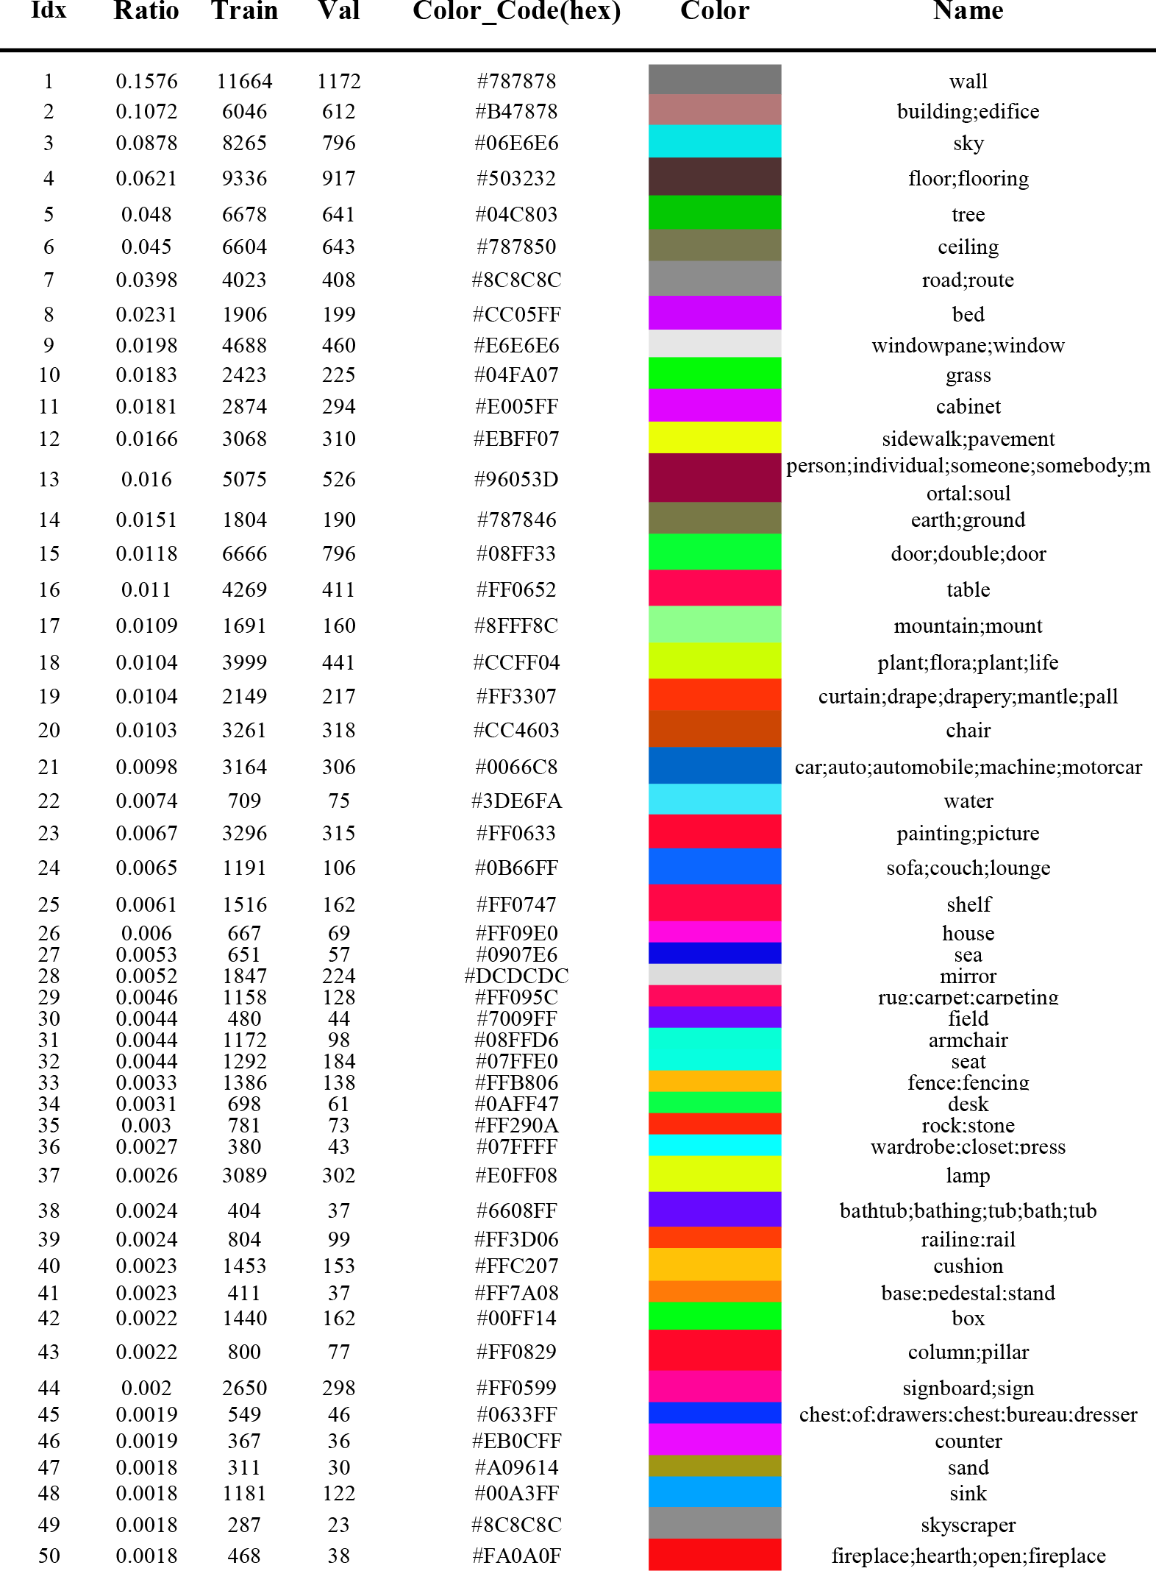

## Appendix B

**Feature Importance of Predictive model**

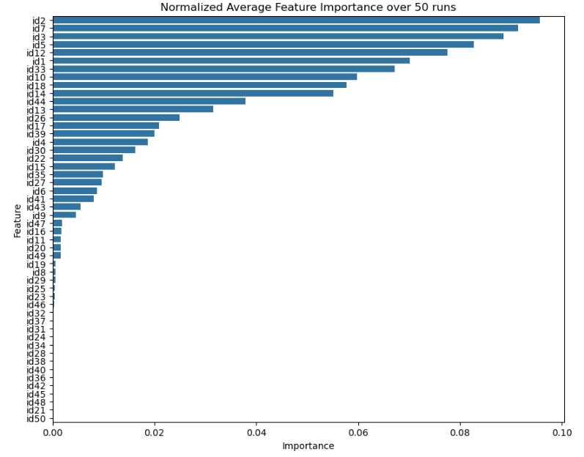

**Figure B. 1**: The average feature importance of LGBoost model

## Appendix C

**POI Category Weight**

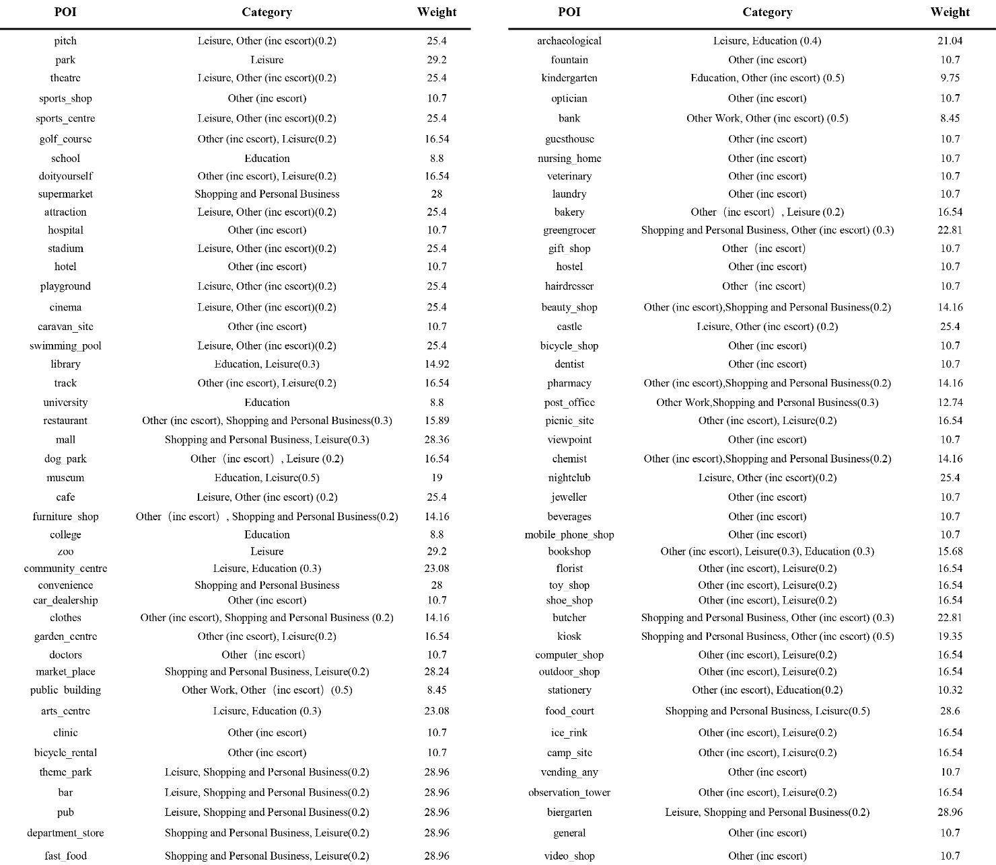

**Table C. 1**: London POI categories and weight

## Appendix D

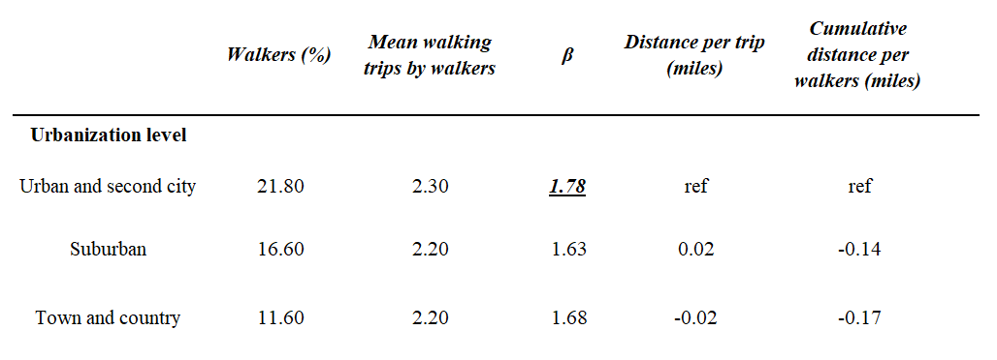**Referenced Distance Decay Parameter**

**Table D. 1**: Distance decay parameter for different urbanization level, adapted from Yang and Diez-Roux (2012)

## Appendix E

**Scripts: GitHub Link**

github.com/ZimengSong1996/15m-city_HSA_Emission_LondonCAZ

## Appendix F

**Research Log**